SUBCOURSE EDITION
OD1512 7

ARTILLERY BATTLEFIELD DAMAGE ASSESSMENT
AND REPAIR



ARTILLERY BATTLEFIELD DAMAGE ASSESSMENT AND REPAIR

SUBCOURSE OD1512
Edition 7

United States Army Combined Arms Support Command
Fort Lee, VA 23801-1809

6 Credit Hours

GENERAL

The purpose of this subcourse is to increase knowledge of the procedures for assessing and repairing battlefield damaged artillery.

Six credit hours are awarded for successful completion of this subcourse. It consists of one lesson of two tasks as follows:

Lesson 1: ASSESSING AND REPAIRING BATTLEFIELD DAMAGED ARTILLERY

TASK 1: Describe the procedures for assessing battlefield damaged artillery.

TASK 2: Describe the procedures for repairing battlefield damaged artillery.

i

ARTILLERY BDAR - OD1512

TABLE OF CONTENTS

Section Page

TITLE i

TABLE OF CONTENTS ii

Lesson 1: ASSESSING AND REPAIRING BATTLEFIELD
DAMAGED ARTILLERY 1

Task 1: Describe the procedures for
assessing battlefield damaged artillery 1

Task 2: Describe the procedures for
repairing battlefield damaged artillery 28

Practical Exercise 1 58

Answers to Practical Exercise 1 60

REFERENCES 61

ii

ARTILLERY BDAR - OD1512 - LESSON 1/TASK 1

LESSON 1

ASSESSING AND REPAIRING BATTLEFIELD
DAMAGED ARTILLERY

TASK 1. Describe the procedures for assessing battlefield damaged artillery.

CONDITIONS

Within a self-study environment and given the subcourse text, without assistance.

STANDARDS

Within two hours

REFERENCES

No supplementary references are needed for this task.

1. Introduction

Battlefield damage assessment and repair procedures are applicable to all combat vehicles and can be used by operator, unit, and intermediate direct support/intermediate general support (IDS/IGS) maintenance personnel under the forward support maintenance concept during combat.

The purpose of battlefield damage assessment and repair is to rapidly return disabled combat vehicles to the operational commander by expediently fixing, bypassing, or jury-rigging components to restore the minimum essential systems required for the support of the specific combat mission, or to enable the vehicle to self-recover. These repairs may be temporary and may not restore full performance capability. For this reason, battlefield damage assessment and repair fixes must be repaired by standard maintenance procedures as soon as practicable after the mission is completed.

1

ARTILLERY BDAR - OD1512 - LESSON 1/TASK 1

There are two technical manuals that deal specifically with battlefield damage assessment and repair (BDAR) for artillery vehicles; TM 9-2350-274-BD and TM 9-2350-276-BD. TM 9-2350-274-BD describes the BDAR procedures applicable to the M109 vehicles and TM 9-2350-276-BD covers expedient repairs of a general nature which apply to more than one combat vehicle. This task will provide the guidelines used to assess battlefield damaged artillery, specifically M109 vehicles.

2. General

a. This task provides an overall damage assessment procedure to evaluate the mobility, communications, and firepower functions of individual artillery vehicles. The assessment procedures are designed to assure that all necessary aspects of a combat vehicle capability are evaluated during the assessment process. The procedures refer the mechanic to:

(1) Procedures in TM 9-2350-274-BD and TM 9-2350-276-BD if a "quick-fix" is possible.

(2) The standard technical manual (TM) if the best repair is covered in the system TM.

(3) A higher maintenance level if access to devices or materials to do the quick-fix are available only at those levels.

b. Each assessment procedure:

(1) Contains general information about the problem.

(2) Lists materials and/or tools required, other than those commonly available to the crew, maintenance team (MT), and maintenance support team (MST). (If the listed items are not available, improvise. Anything that will do the job is acceptable.)

(3) Lists the estimated number of soldiers needed, and the estimated time required to complete the repair.

2

ARTILLERY BDAR - OD1512 - LESSON 1/TASK 1

(4) States the operational limitations caused by the repair action to prevent further damage/degradation to the vehicle.

(5) Provides other expedient options that the mechanic can use, depending on the availability of personnel, materials, tools, and/or time (this does not include standard maintenance procedures or recovery).

c. Following each assessment procedure in the BDAR technical manual is an index of the procedures contained within that chapter. If the mechanic knows exactly what the problem is, he can use the index to find the most expedient repair procedure.

d. Additional data on a battlefield damaged artillery vehicle, specifically the M109 howitzer, is contained in the Appendices of TM 9-2350-274-BD.

(1) Appendix A lists alternate sources of supply, to include foreign ownership to US combat vehicles, and expendable supplies which are recommended for use to implement various BDAR repairs.

(2) Appendix B lists special or fabricated tools used in performing BDAR repairs.

(3) Appendix C lists substitutes for the petroleum, oil, and lubricants (POL).

3. Assessment Process

a. The assessment procedures are structured using the logic process shown in figure 1 on the following page.

All assessment procedures follow the sequence:

(1) Visually inspect (repair, if necessary).

(2) Functionally test (repair, if necessary).

(3) Assess the performance.

The field fixes will enable the crew to continue operations in some cases, but will usually be most useful to the MT/MST for scheduling and accomplishing fix-forward repairs and assessing combat capabilities to be reported to commanders.

3

ARTILLERY BDAR - OD1512 - LESSON 1/TASK 1

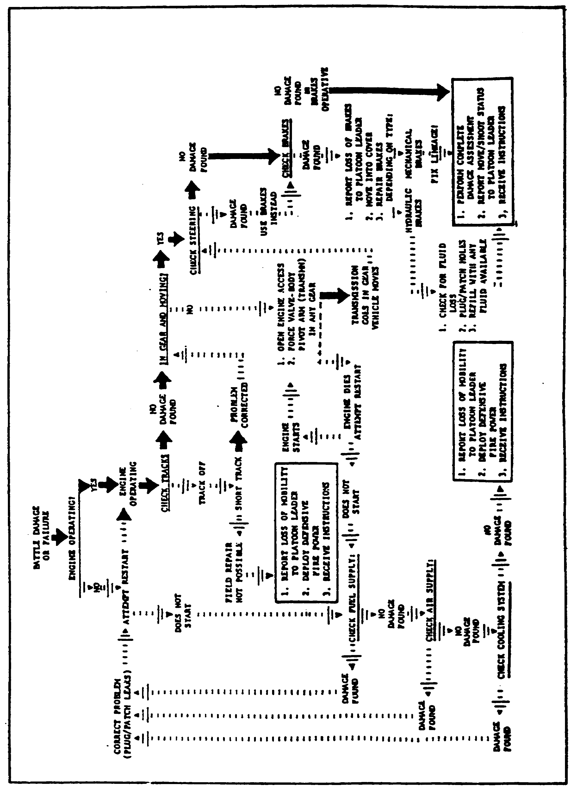

FIGURE 1. BATTLEFIELD DAMAGE ASSESSMENT
PROCESS.

4

ARTILLERY BDAR - OD1512 - LESSON 1/TASK 1

b. There are three kinds of assessments performed on damaged equipment:

(1) The first is the extent and type of damage and how it affects vehicle operation and capabilities.

(2) The second is whether the damage needs to be repaired.

(3) The third is where and how to repair the damage.

c. Assessments of damage may be made in turn by operator/crew, MT, and MST assessors. The assessments that they perform are:

(1) Is the extent and type of damage readily assessable?

(2) Whether or not damage to be repaired is readily assessable. However, whether to attempt repair and when and how to repair the damage may be judgment calls. No procedure can take all possible situations into account. Assessment of whether the damage needs to be repaired will be made jointly by the MT and vehicle commander to determine whether further operation or recovery is appropriate.

(3) Assessment of where and how to repair the damage will be made by the MT, usually with some suggestions by crew/operator. MSTs may redirect or change MT's decisions.

4. Overall Vehicle Assessment Procedure a. This procedure can be used by the crew, but it will be of more use to a MT or MST assessor working to "quick-fix" vehicles for a mission or self-recovery. The procedure provides for assessing the kind of damage and determining:

(1) The effect of the damage and if it needs to be fixed.

(2) If the damage can be fixed using BDAR or if only regular maintenance operations can fix it.

(3) How long it will take to fix it.

b. This is accomplished by structuring the specific vehicle's BDAR manual in rank order, from

5

ARTILLERY BDAR - OD1512 - LESSON 1/TASK 1

the vehicle three-function overview down to the specific. Each major function (shoot, move, communicate) and each subsystem that makes up a part of providing that function, has a stand-alone assessment procedure, making it easier to quantify each significant problem encountered in battlefield damaged equipment.

c. As an example, a vehicle develops an engine speed control problem. The overall vehicle assessment table directs the user to perform a number of visual and functional checks, which will narrow down the number of areas possibly at fault. The overall vehicle assessment table provides references to chapter and/or sections dealing with a subsystem in which the problem may be found. Additional assessment procedures in that chapter will either eliminate further assessment in that area or confirm the likelihood of a problem in that area by directing the user to check out specific assemblies or components. Assessment procedures in the beginning of each Chapter provide references to specific paragraphs which may expediently solve the problem. At any point on each of the assessment levels, the assessor can abort the procedure and direct recovery, evacuation or other actions if the tactical situation dictates.

5. Vehicle/System Assessment

Items checked in a vehicle/system assessment procedure must work to provide minimum functional combat capability. Even if all systems work, the vehicle may be unsafe and may not satisfy normal required operating capabilities or may not receive mission-essential maintenance. Table I will describe the assessment procedure for mobility, armament and fire control, and communications of an artillery vehicle, particularly the M109 howitzer.

TABLE 1. VEHICLE/SYSTEM ASSESSMENT.

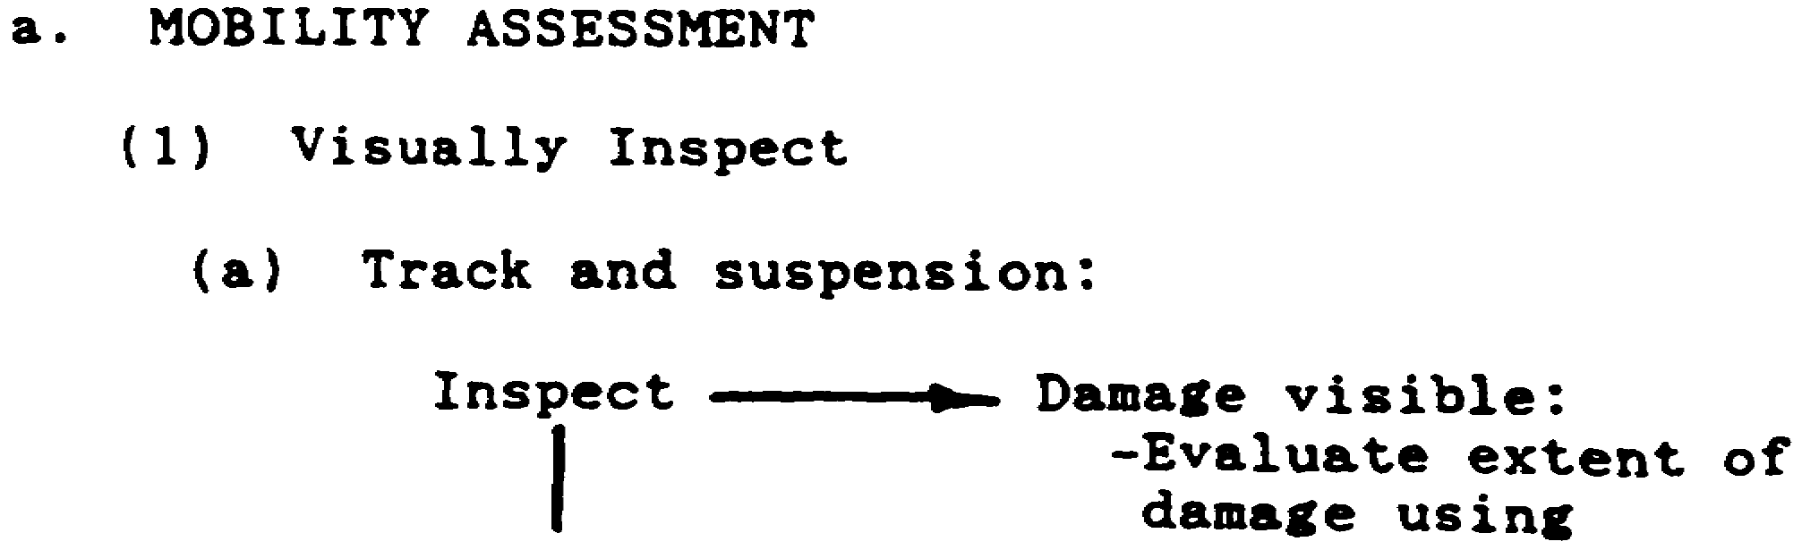

6

ARTILLERY BDAR - OD1512 - LESSON 1/TASK 1

TABLE 1. VEHICLE/SYSTEM ASSESSMENT (Continued).
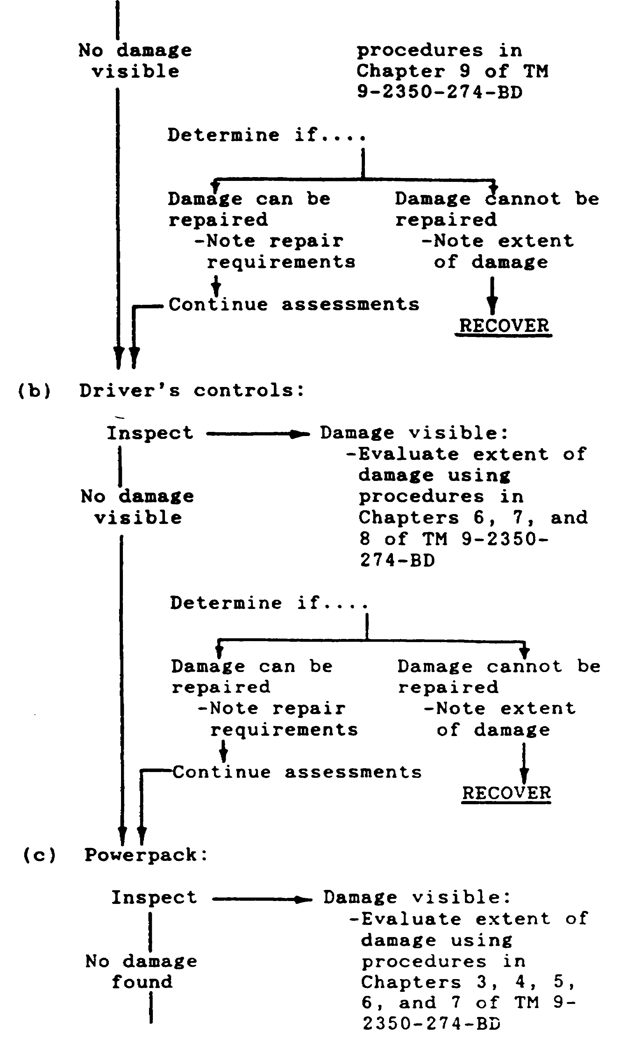

7

ARTILLERY BDAR - OD1512 - LESSON 1/TASK 1

TABLE 1. VEHICLE/SYSTEM ASSESSMENT (Continued).

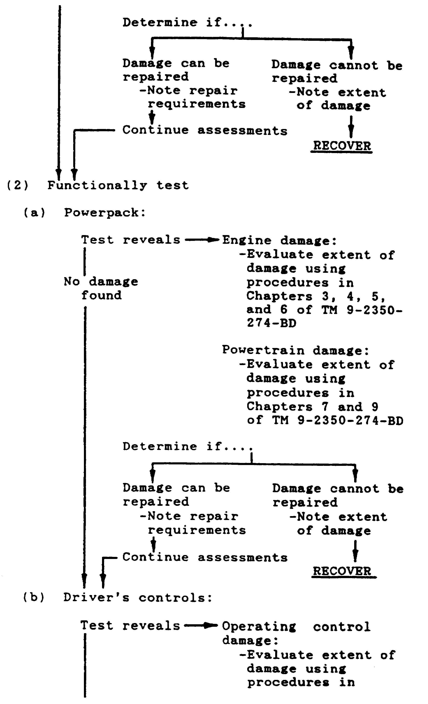

8

ARTILLERY BDAR - OD1512 - LESSON 1/TASK 1

TABLE 1. VEHICLE/SYSTEM ASSESSMENT (Continued).

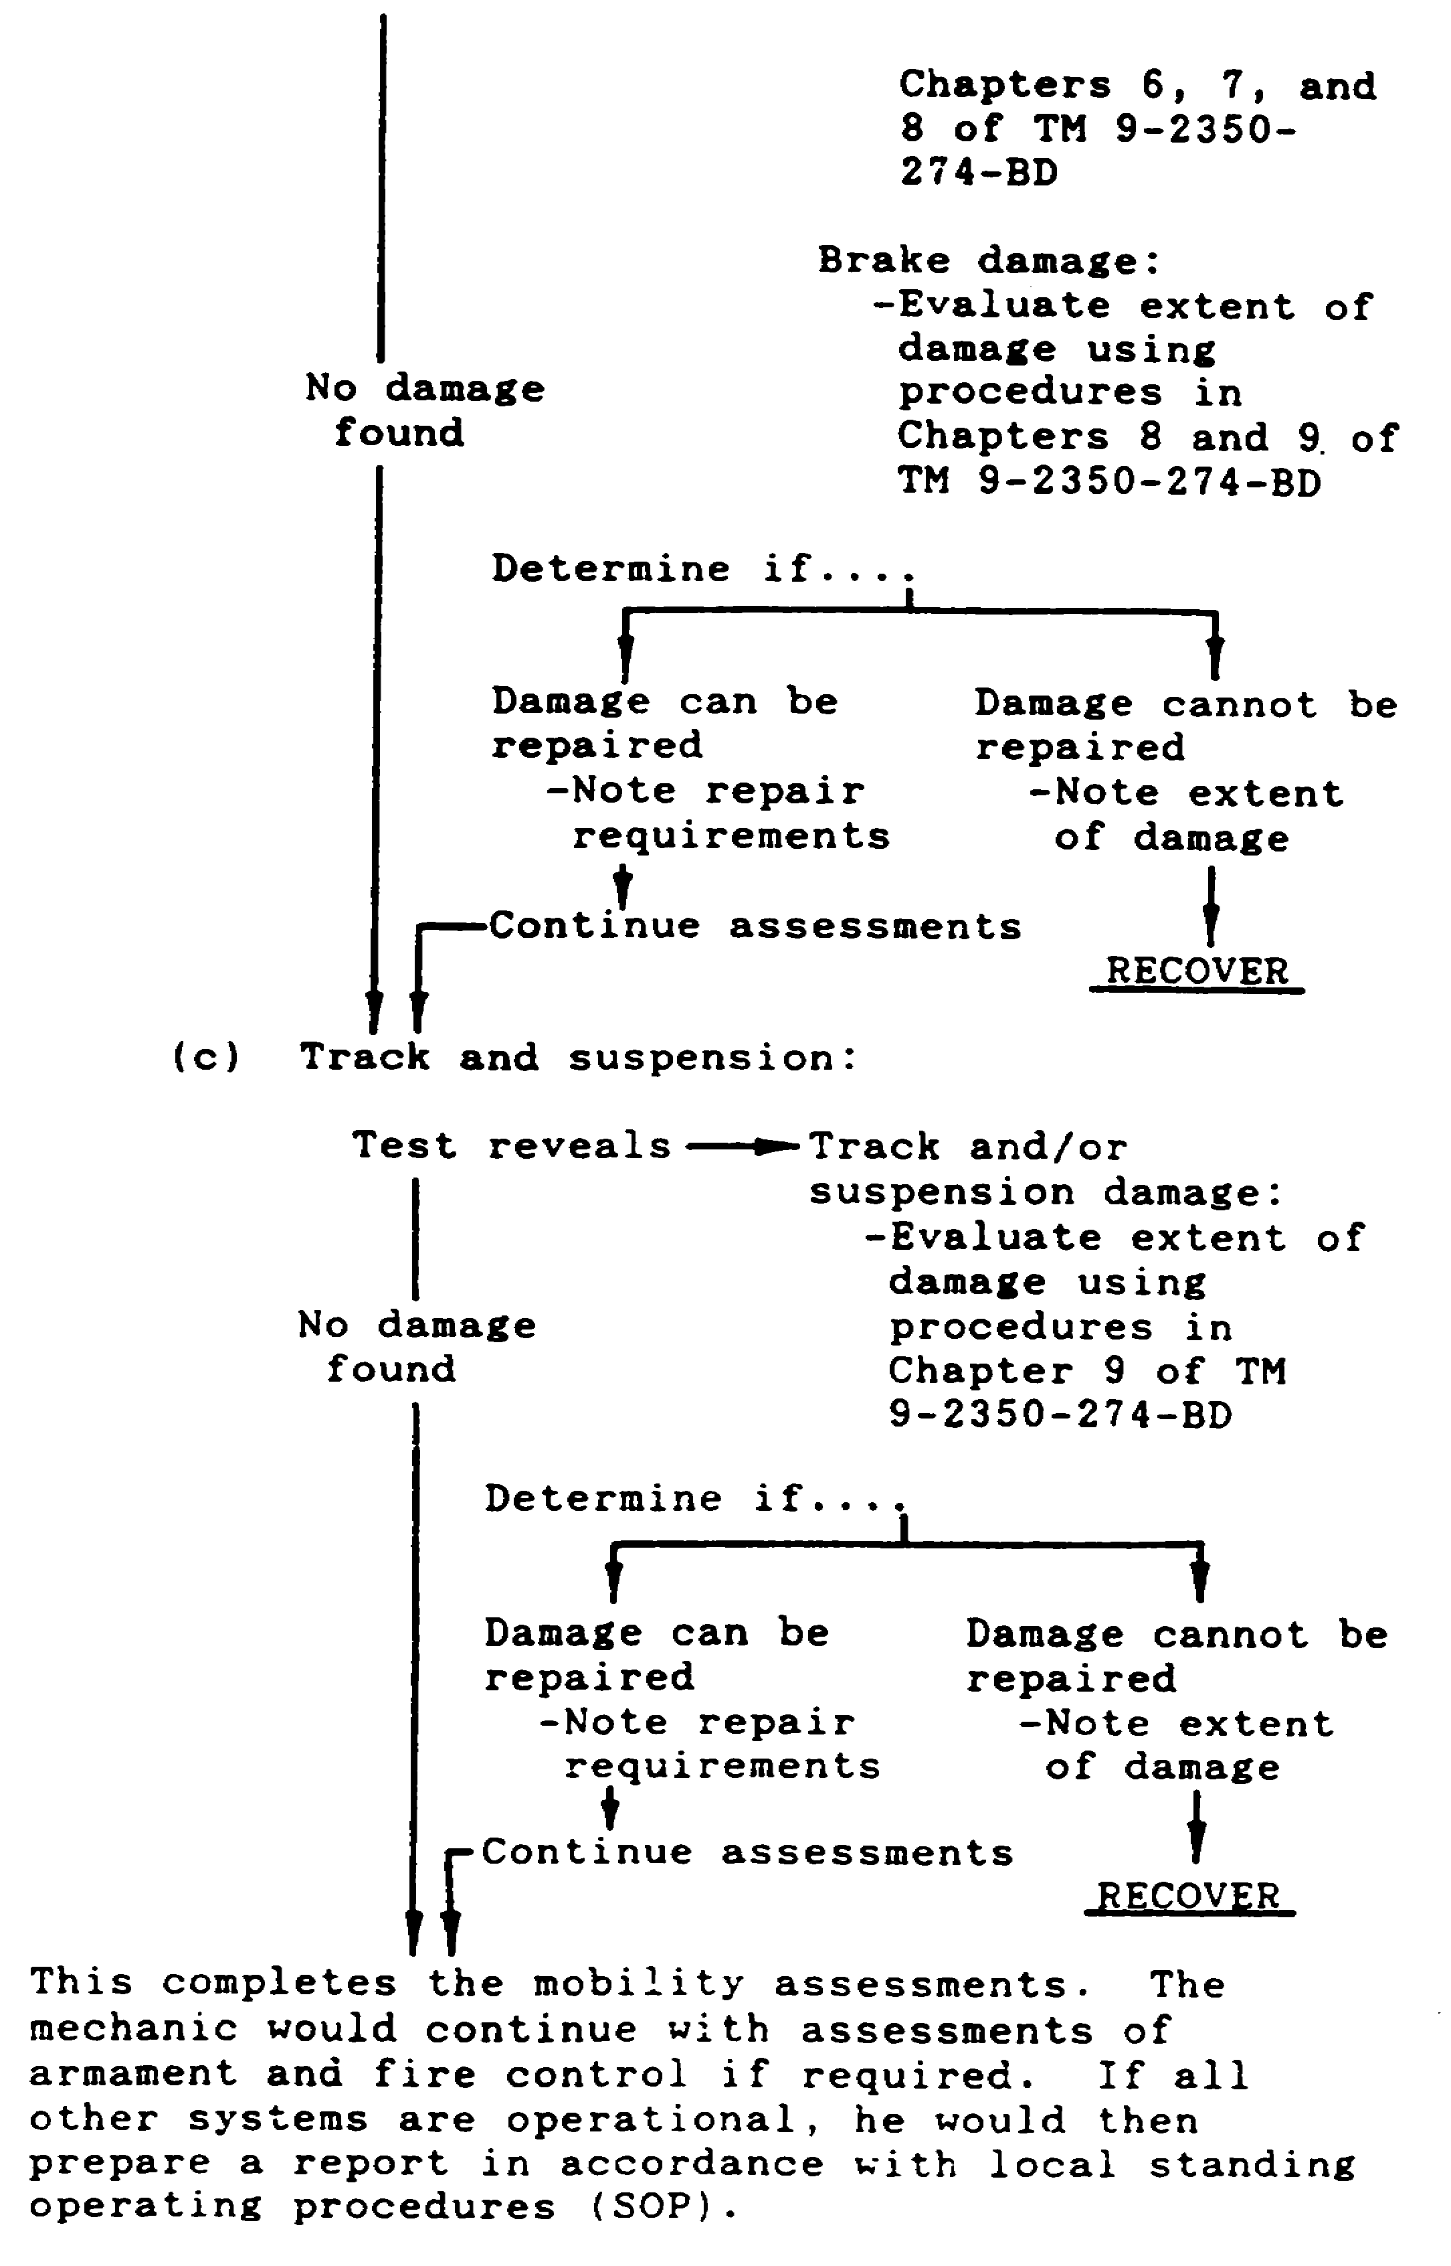

9

ARTILLERY BDAR - OD1512 - LESSON 1/TASK 1

TABLE 1. VEHICLE/SYSTEM ASSESSMENT (Continued).

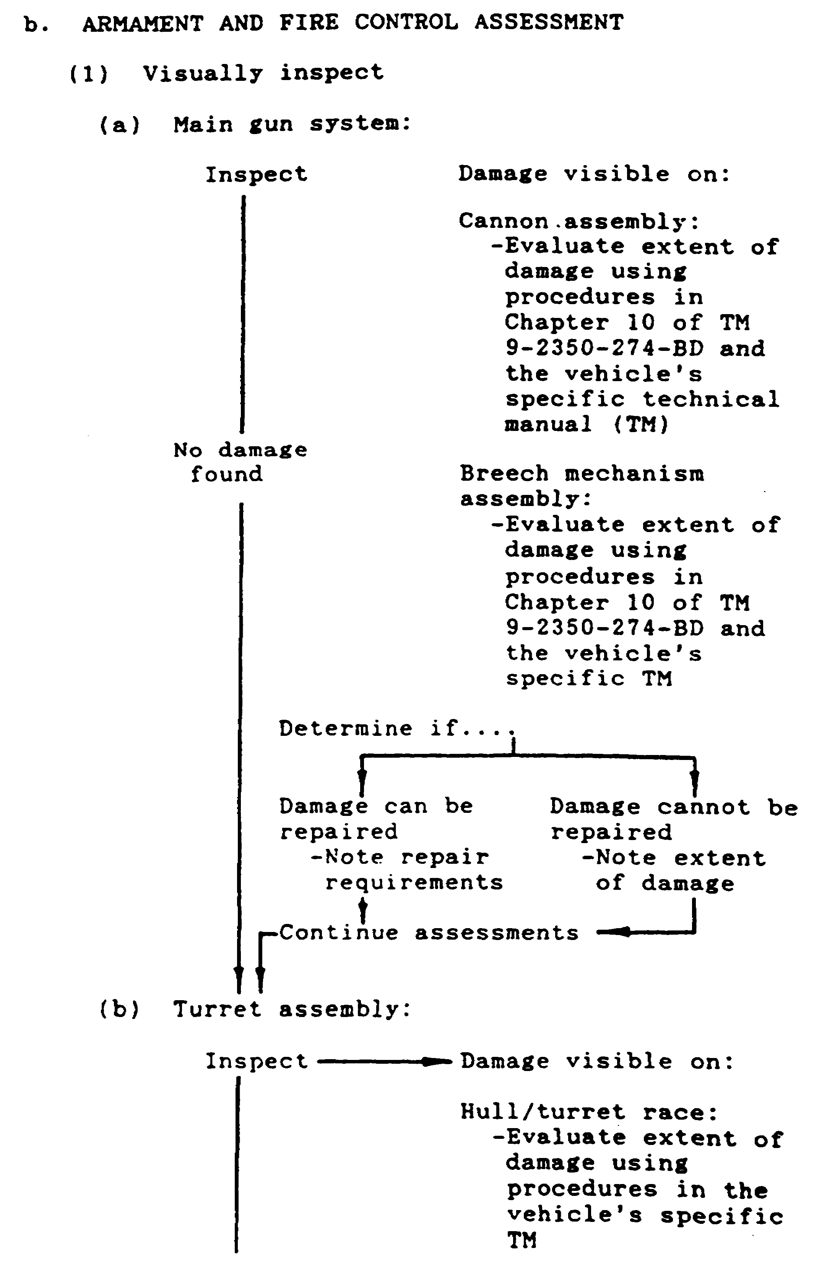

10

ARTILLERY BDAR - OD1512 - LESSON 1/TASK 1

TABLE 1. VEHICLE/SYSTEM ASSESSMENT (Continued).
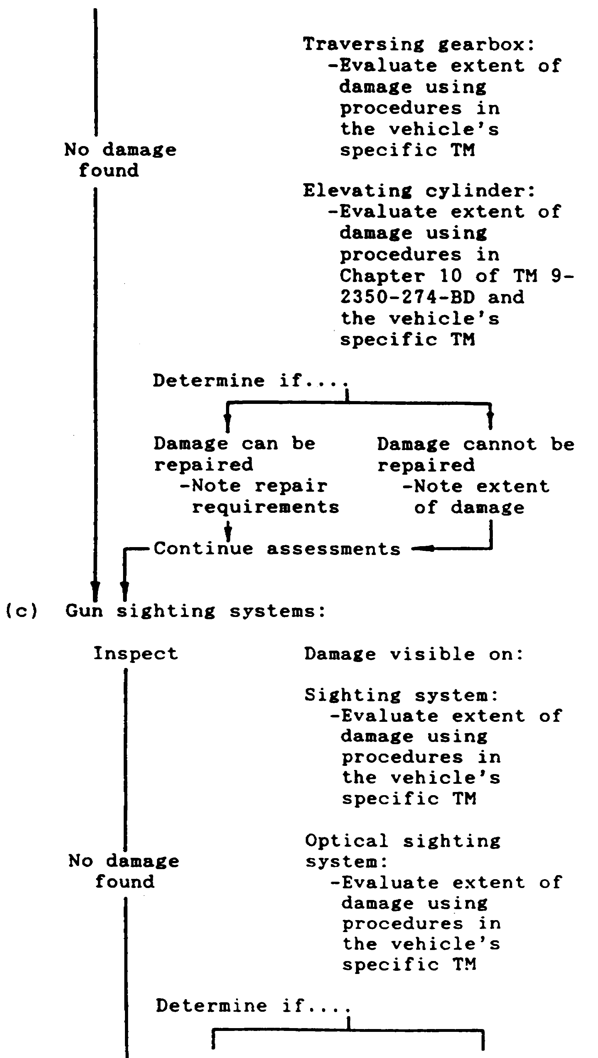

11

ARTILLERY BDAR - OD1512 - LESSON 1/TASK 1

TABLE 1. VEHICLE/SYSTEM ASSESSMENT (Continued).

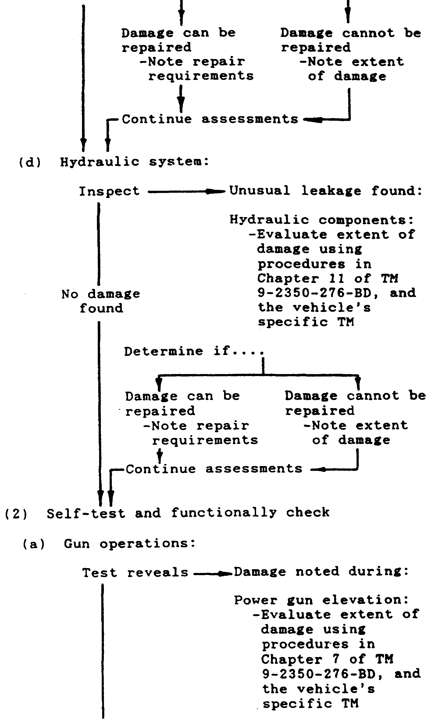

12

ARTILLERY BDAR - OD1512 - LESSON 1/TASK 1

TABLE 1. VEHICLE/SYSTEM ASSESSMENT (Continued).
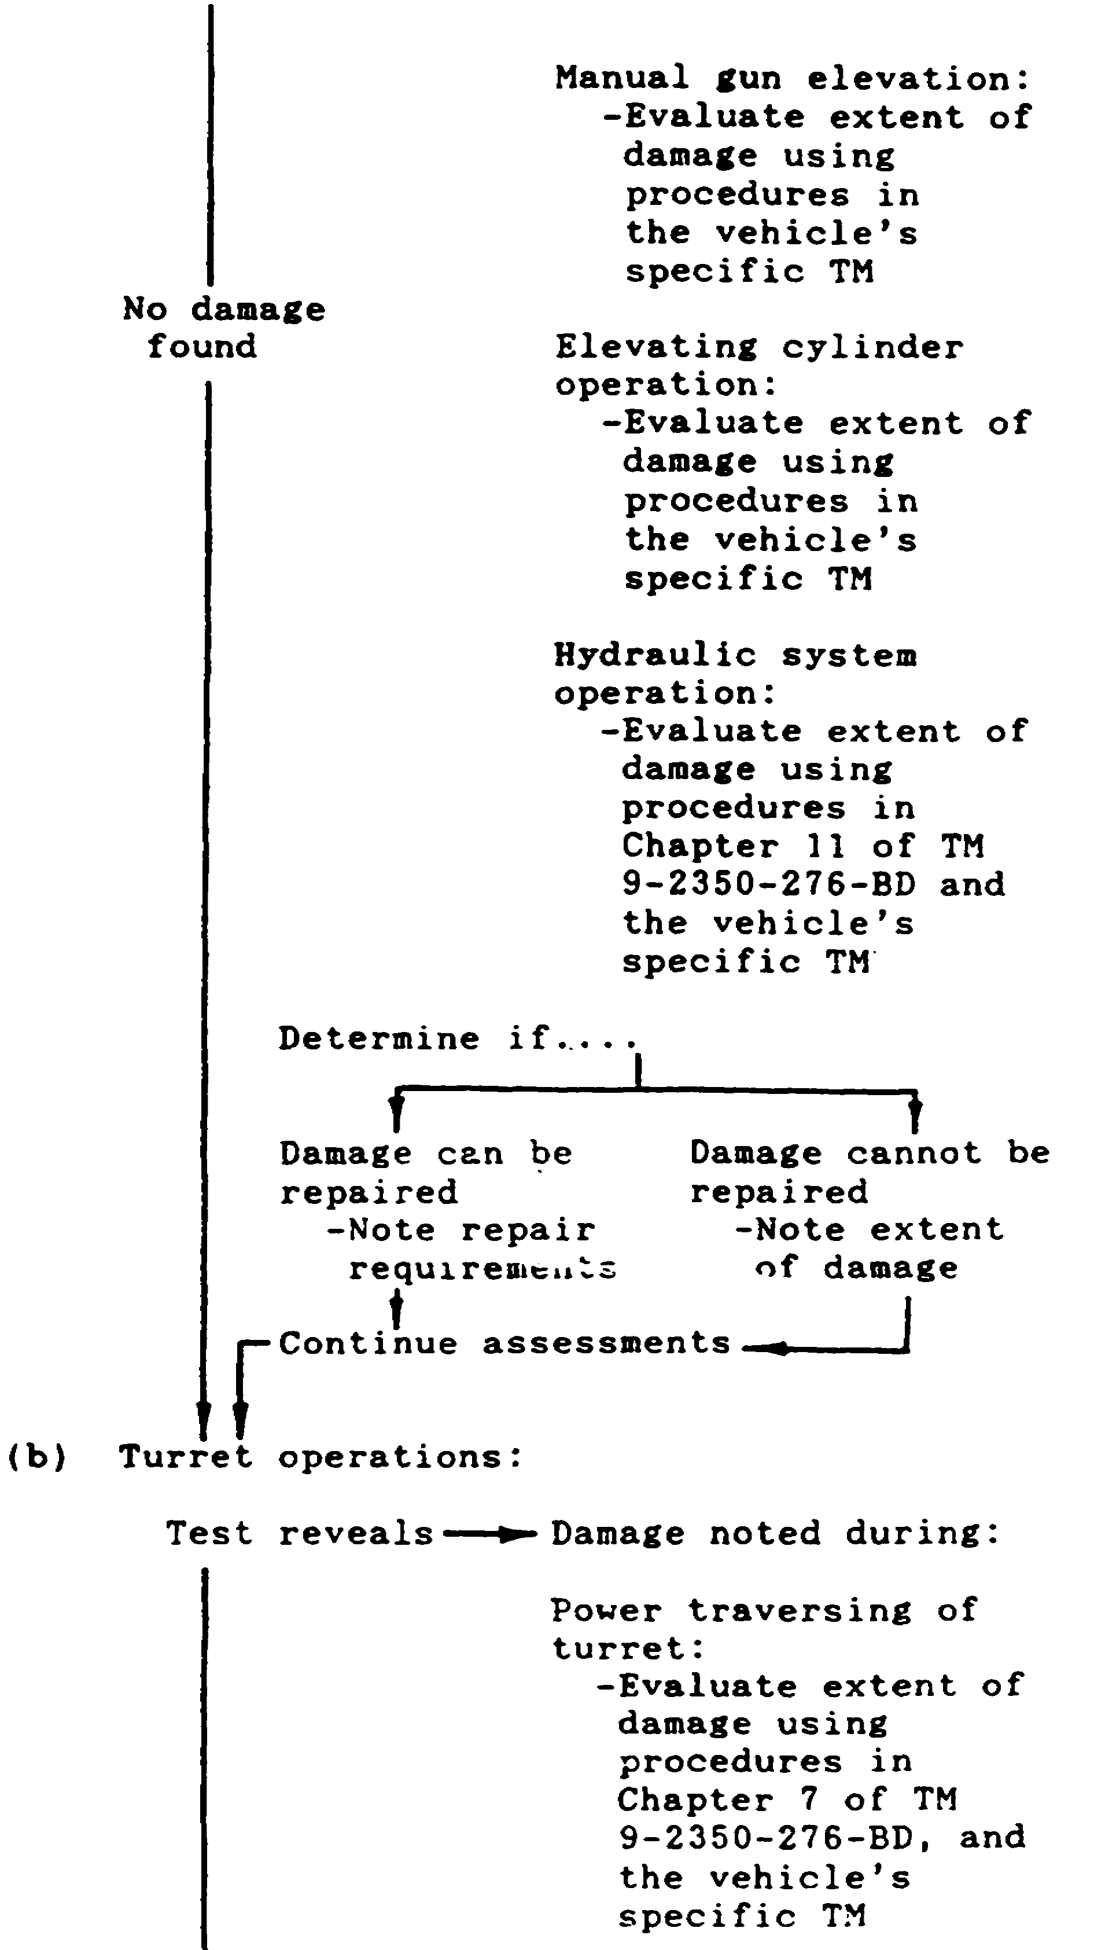

13

ARTILLERY BDAR - OD1512 - LESSON 1/TASK 1

TABLE 1. VEHICLE/SYSTEM ASSESSMENT (Continued).
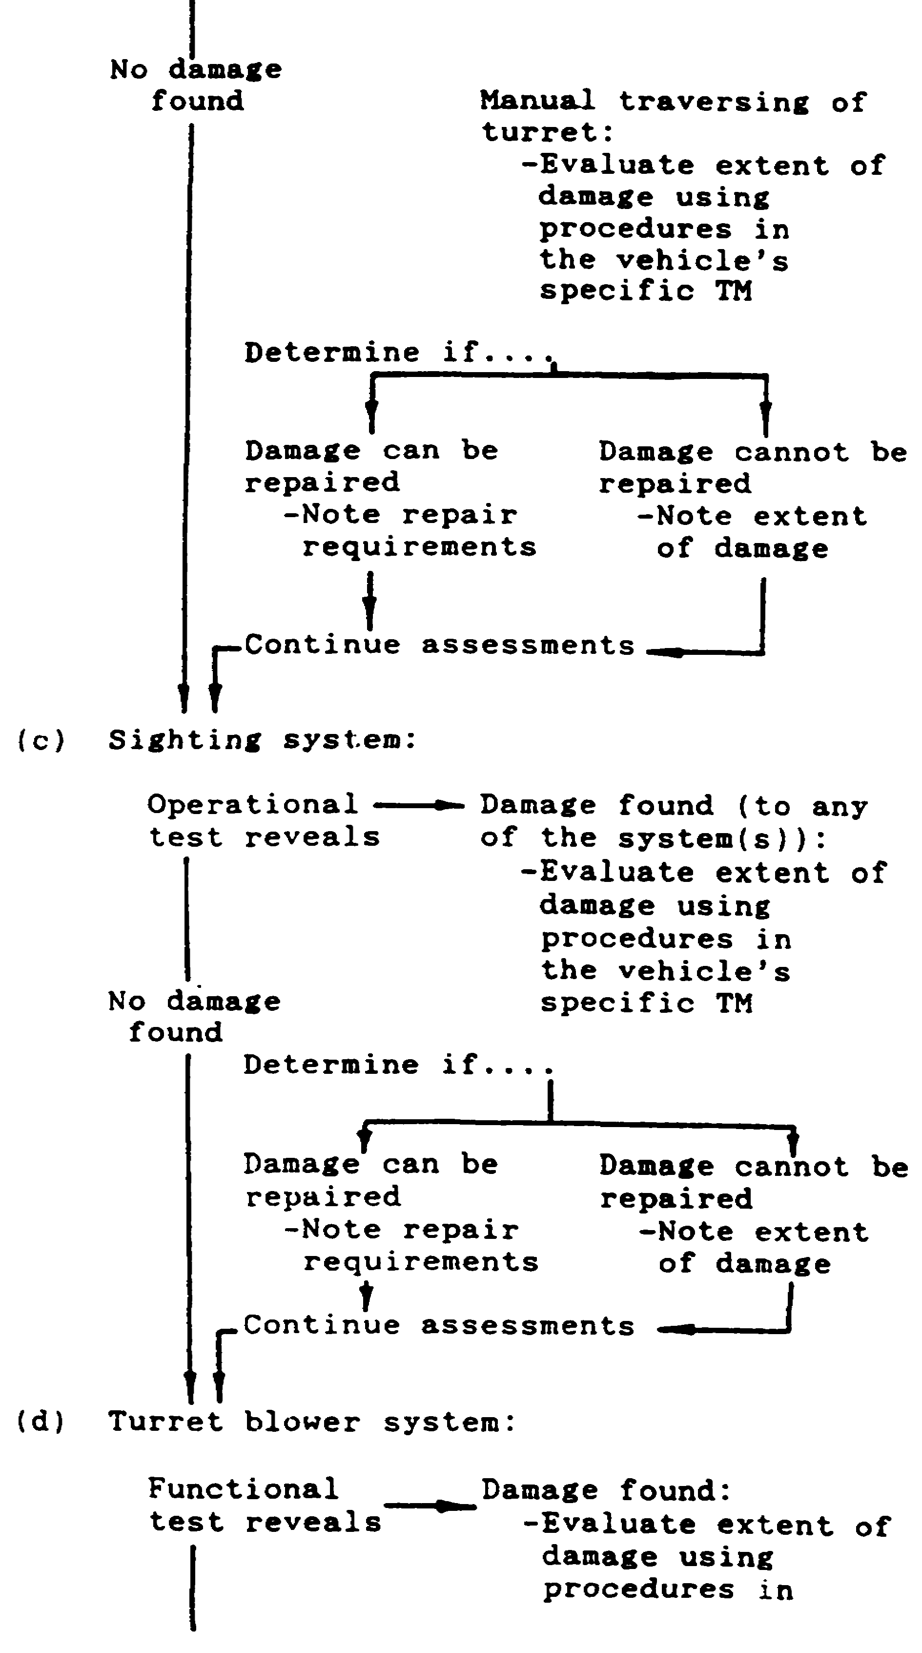
14

ARTILLERY BDAR - OD1512 - LESSON 1/TASK 1

TABLE 1. VEHICLE/SYSTEM ASSESSMENT (Continued).

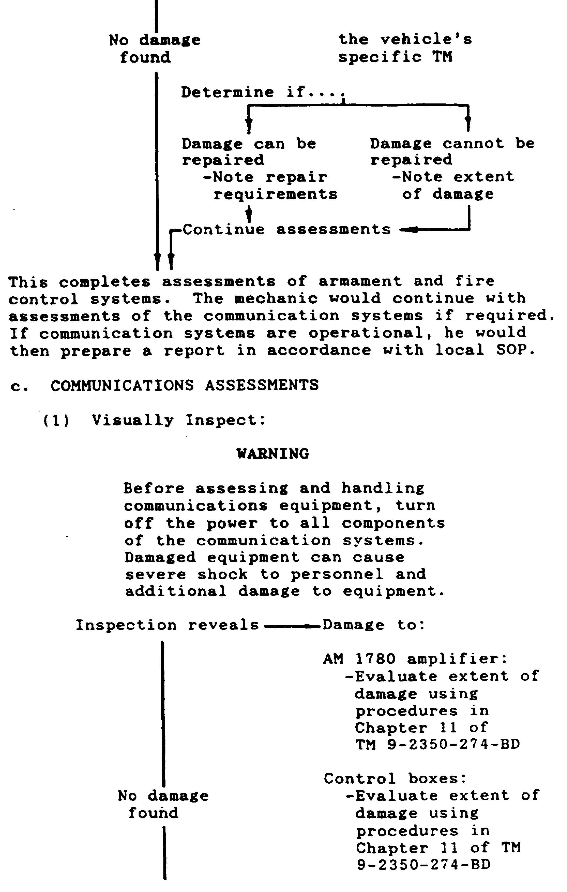

15

ARTILLERY BDAR - OD1512 - LESSON 1/TASK 1

TABLE 1. VEHICLE/SYSTEM ASSESSMENT (Continued).

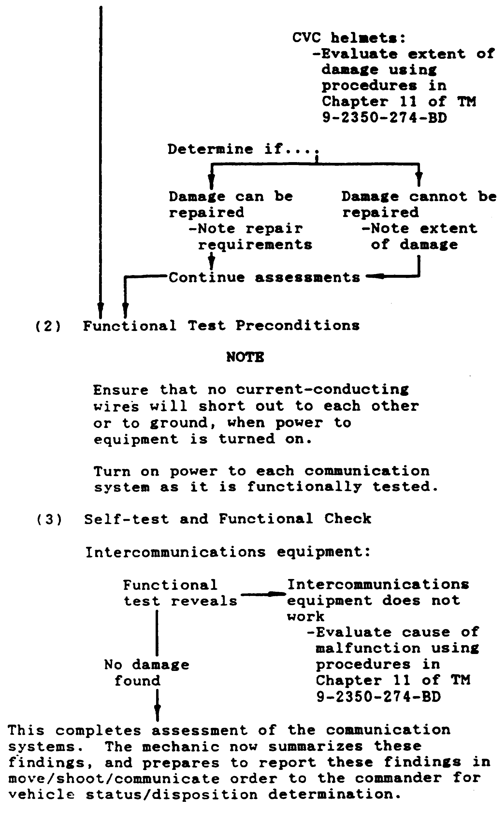

16

ARTILLERY BDAR - OD1512 - LESSON 1/TASK 1

6. Battlefield Damage Assessment/Repair Forms (BDARFs)

a. This paragraph illustrates and describes the forms used in battlefield damage assessment. The forms are designed to assist commanders in rapidly assessing battlefield damaged equipment, systematically assessing equipment to determine which subsystem(s) are affected, and the time, personnel, and material required to effect repair. These forms will also assist in performing "vehicle triage." Vehicle triage is defined as a system of deciding in which order battlefield damaged equipment will receive repair, according to time, urgency, material and personnel required to accomplish the repair. The forms illustrated on the following pages are to be used in assessing battlefield damage.

NOTE

These forms are locally reproducible and should be reproduced in necessary quantities to support local needs.

b. The battlefield damage assessment/repair forms are designed to assure that all necessary aspects of combat capability are evaluated during the assessment process.

c. All assessment procedures follow the sequence, (1) visually inspect (repair if necessary), (2) functionally test (repair if necessary), and (3) assess the performance. The net assessment and field fixes may enable the vehicle to continue the mission or self-recover, but will typically be more useful to the MT/MST for scheduling and accomplishing both BDAR "quick-fixes" and fix-forward repairs. Battlefield damage assessment will also provide the commander with necessary information for timely decisions as to whether to continue to "fight the vehicle" or recover it at the appropriate level.

d. Reporting of battlefield damage should be accomplished in accordance with local standing operating procedures (SOPs).

e. There are four forms to be used when assessing battlefield damaged artillery: BDARF-5 (System Summary), BDARF-6 (Hull Damage Report), BDARF-7 (Turret Damage Report), and BDARF-8 (Communications

17

ARTILLERY BDAR - OD1512 - LESSON 1/TASK 1

Damage Report). These forms can be used by the crew, a MT, or a MST.

(1) BDARF-5 (see figure 2 on the following page) is used to determine:

(a) Can the vehicle move, shoot, and communicate?

(b) What subsystems are affected?

(c) Is the damage repairable?

(d) If repairable, are there limitations?

(e) Estimated time to repair?

(f) Estimated number of personnel to effect repair?

(g) What materials are required?

(h) Recover status (recovery vehicle required or self-recovery).

Once these questions are answered, a determination can be made as to whether the vehicle should be repaired on-site, recovered to a collection point and repaired, or recovered to the rear.

(2) BDARF-6, BDARF-7, and BDARF-8 .(see figures 3, 4, and 5 on pages 20 through 23) address specific systems and subsystems. These forms are designed to assist the assessor to rapidly determine the appropriate BDAR fix. The portion of this form which addresses parts should be filled out only when the tactical situation permits. Where possible, these forms should follow the damaged equipment or be sent to the rear as a record of what damages occurred and what repairs were effected and where.

7. Test Equipment

a. Field Expedient Test Equipment. Sometimes, in the process of assessing the battlefield damage, it is necessary to make voltage and resistance measurements to determine where the fault is. Standard test equipment (voltmeter, ohmmeter, standing wave ration (SWR) meter, etc.) should be used whenever possible.

18

ARTILLERY BDAR - OD1512 - LESSON 1/TASK 1

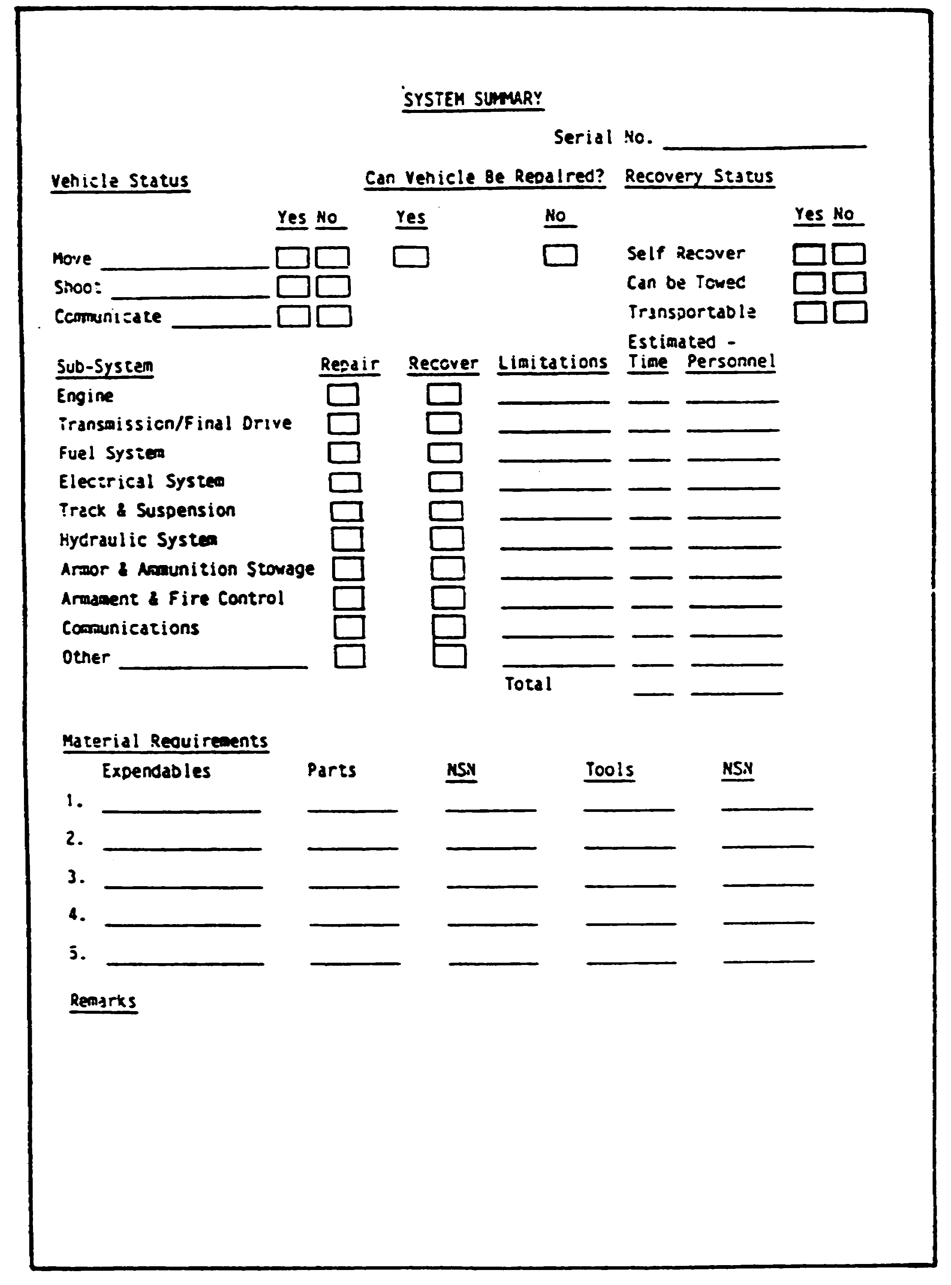

FIGURE 2. BDARF-5.

19

ARTILLERY BDAR - OD1512 - LESSON 1/TASK 1

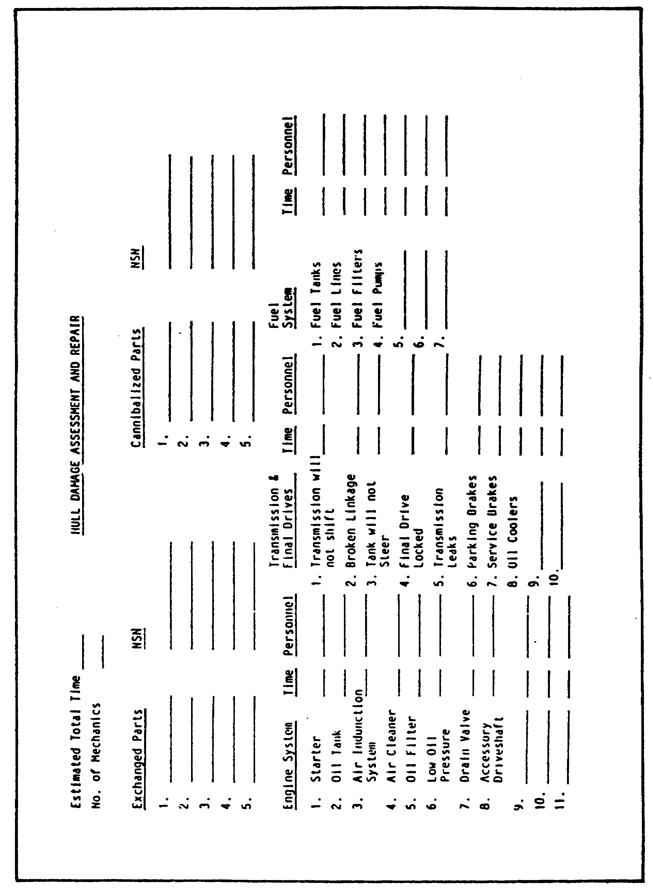

FIGURE 3A. BDARF-6.

20

ARTILLERY BDAR - OD1512 - LESSON 1/TASK 1

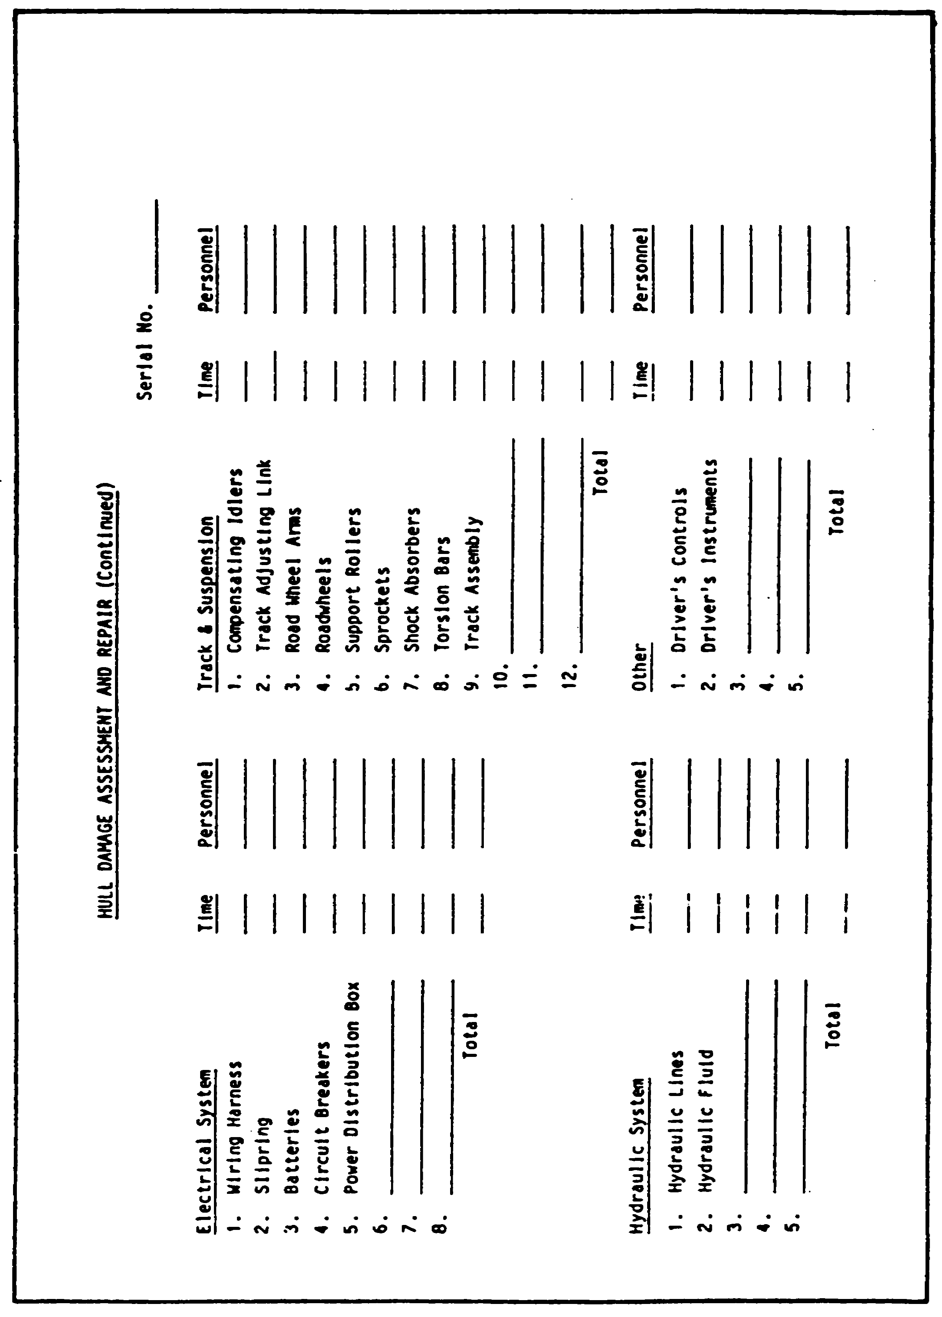

FIGURE 3B. BDARF-6 (CONTINUED).

21

ARTILLERY BDAR - OD1512 - LESSON 1/TASK 1

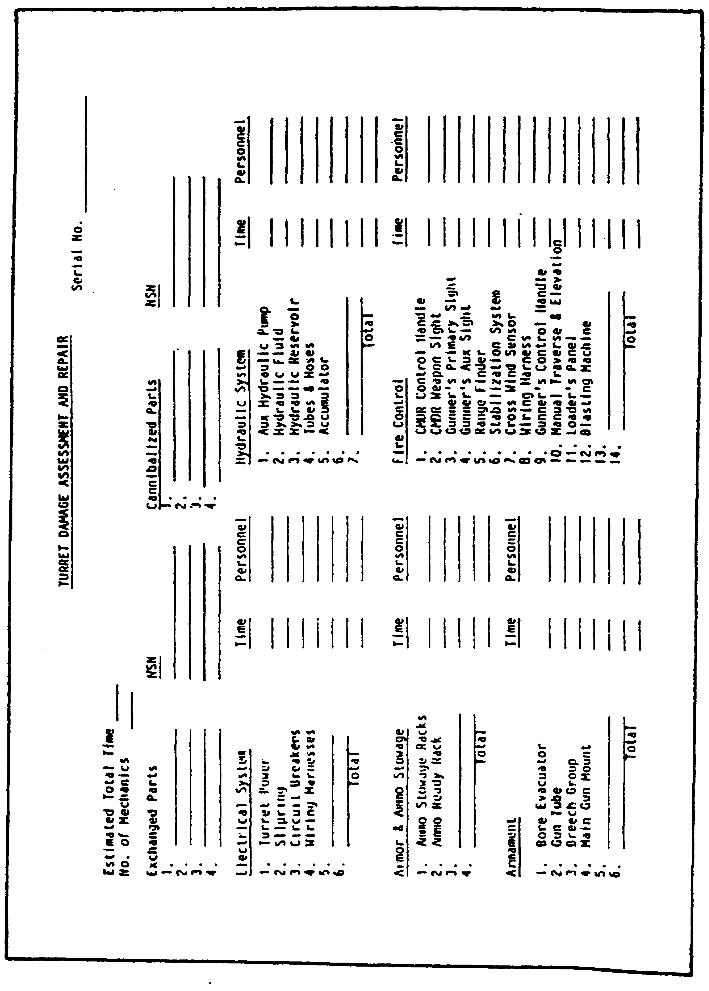

FIGURE 4. BDARF-7.

22

ARTILLERY BDAR - OD1512 - LESSON 1/TASK 1

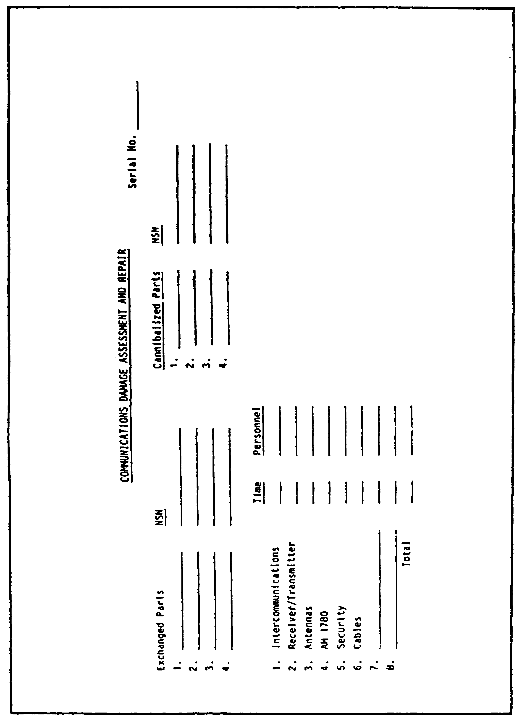

FIGURE 5. BDARF-8.

23

ARTILLERY BDAR - OD1512 - LESSON 1/TASK 1

If standard test equipment is not available, field expedient equipment can be fabricated, using parts commonly found on the vehicle and in the forward maintenance areas. The following paragraphs provide fabrication instructions for making a voltmeter, ohmmeter, and radio frequency (RF) transmitter output tester.

(1) Voltmeter. A voltmeter can be made from a light bulb and two pieces of wire. The pieces of wire can be connected to the case and the center terminal of the bulb by solder, twisting, or holding the wire ends against the bulb (see figure 6 on the following page). The voltage rating of the bulb should be close to the value of the expected voltage being measured. For voltages in the 18 to 30 volts direct current (vdc) range, any light bulb on the driver's master panel, driver's instrument panel, gunner's panel, commander's panel, or gunner's primary sight can be used. For voltages of 5 vdc or less, a two-battery cell flashlight bulb can be used. The presence of voltage will cause the bulb to glow. Polarity of voltage does not have to be observed, so alternating current (ac) voltage can also be measured, if necessary.

(2) Ohmmeter (Continuity Tester). An ohmmeter can be made from a flashlight bulb, flashlight battery, and three pieces or wire (see figure 7 on page 26). When the free ends of the wires are touched to a circuit where continuity (or a short) exists, the bulb will glow. If a two-cell flashlight bulb is used with only one battery, the bulb will glow with one-half its normal brilliance..

(3) RF Transmitter Output Tester. The output tester is used to determine if the radio in the vehicle is sending a signal to the antenna. The following subparagraphs provide two ways of fabricating a RF transmitter output tester.

(a) A RF transmitter output tester can be made from a neon light bulb and a piece of CO-1773 RF cable. Solder the bulb to the cable, as shown in figure 8 on page 26. Connect the cable to the ANT connection on the front of the radio. When the radio is keyed, the bulb will glow if RF power is present at the antenna connection (this does not verify transmitter frequency accuracy).

24

ARTILLERY BDAR - OD1512 - LESSON 1/TASK 1

(b) Another way to check for transmitter output is to hold a common (wood) lead pencil tip 1/4 inch to 1/8 inch from the ANT connection. If RF power is present, a yellowish-white arc will jump from the connector to the pencil tip when the radio is keyed.

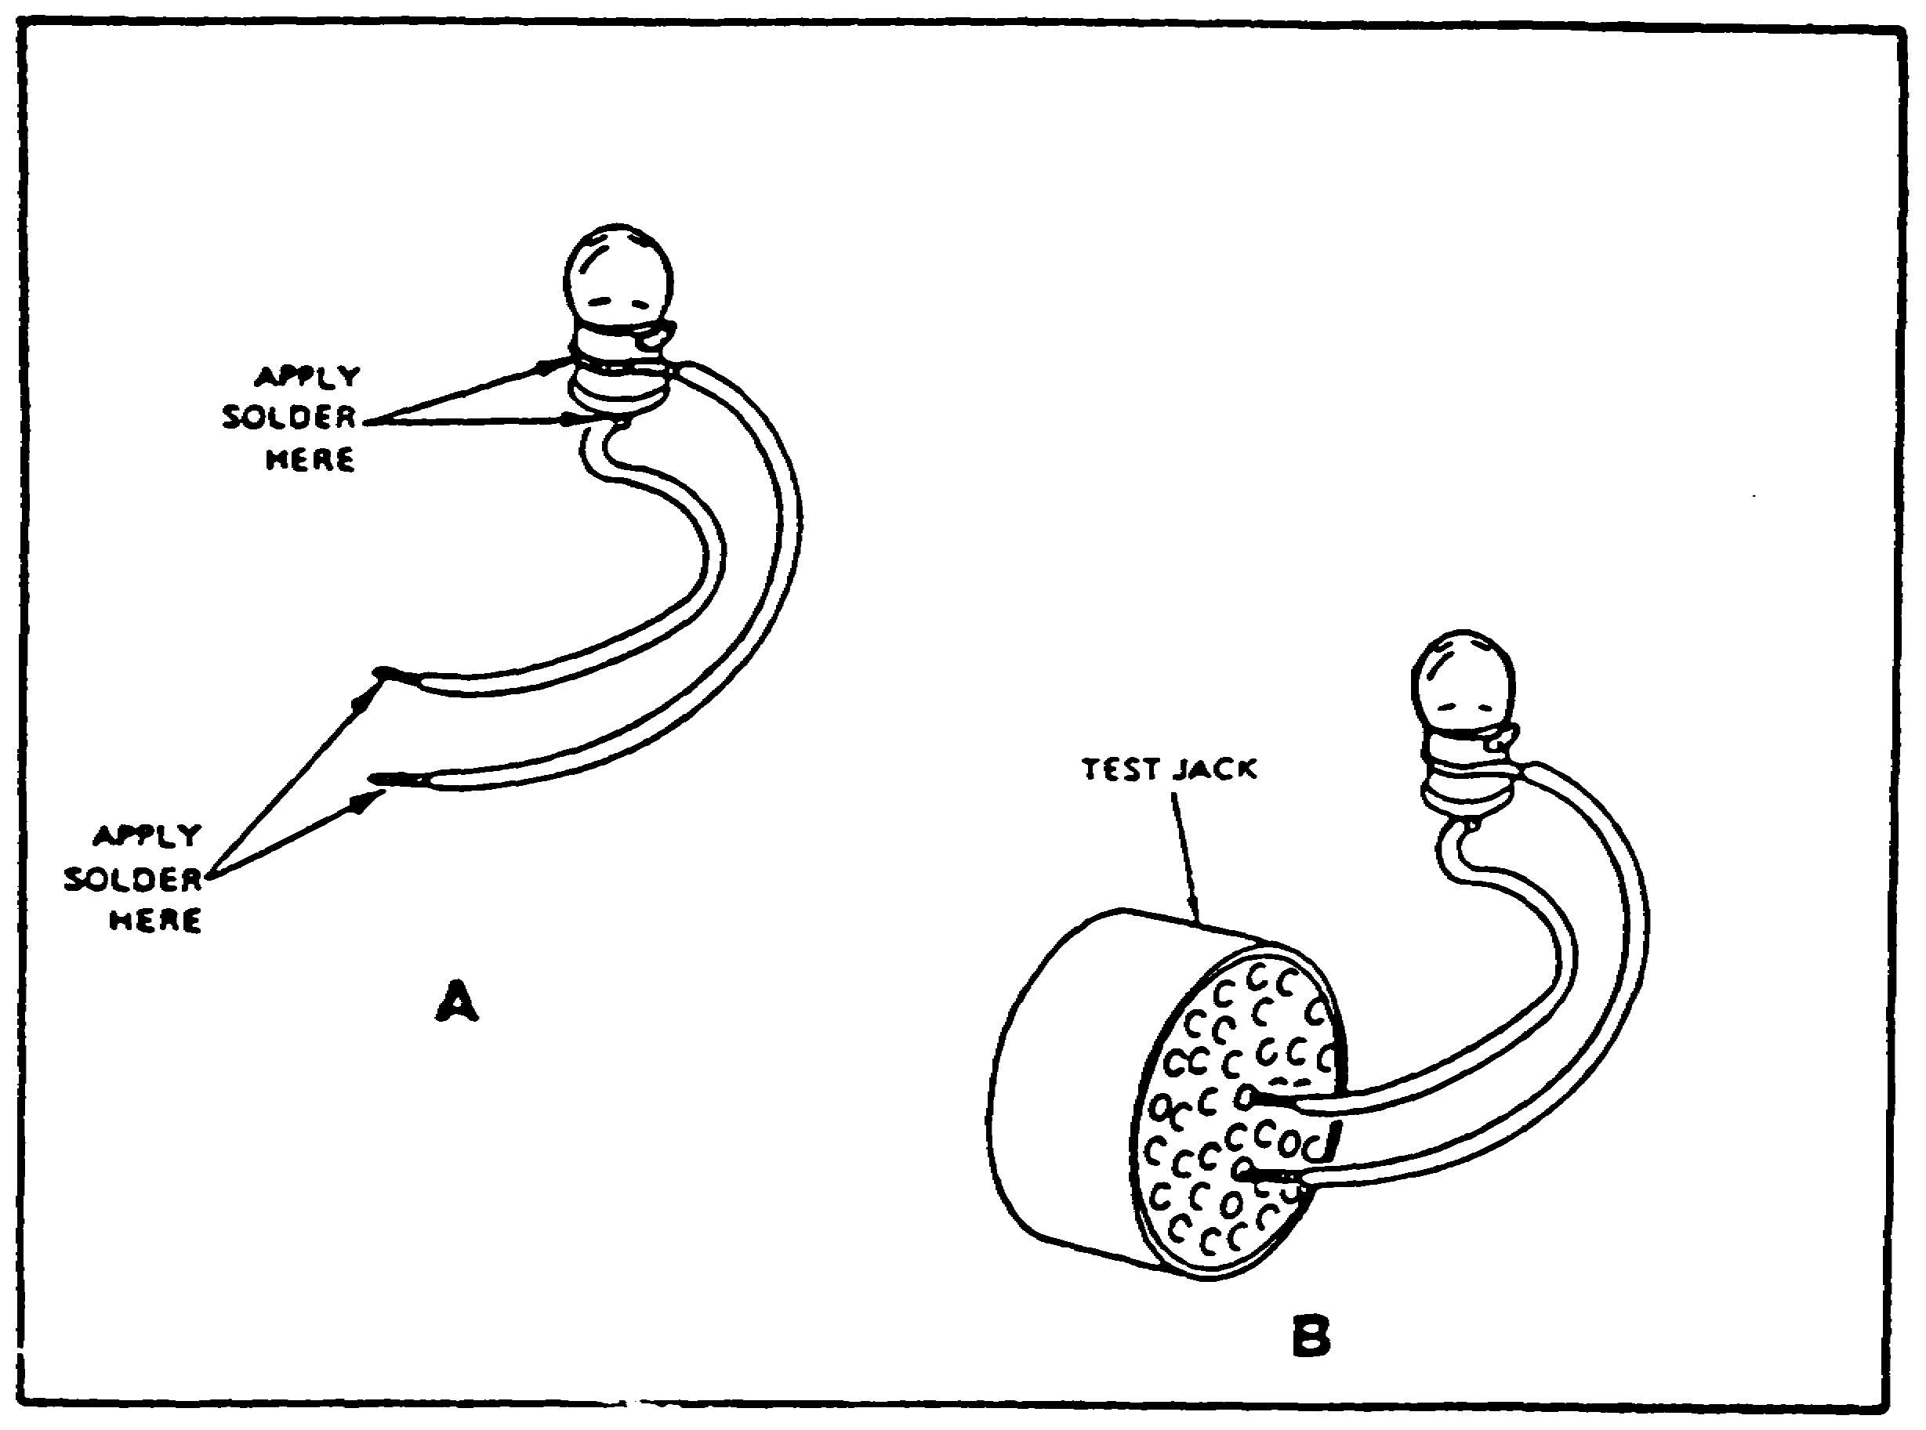

FIGURE 6. FABRICATED VOLTMETER.

(4) Antenna Output Tester. The antenna output tester is used to determine if the radio is sending a signal from the antenna; it is fabricated as follows:

(a) An antenna output tester can be made from a light emitting diode (LED) and a piece of 10, 12, or 14 gauge wire. Bend an 18 inch piece of wire into a triangle, with the open ends meeting at about a 60 degree angle (see figure 9 on page 27). Add an insulator or other hand grip to the tester for safety. Solder the diode across the open ends of the wire.

25

ARTILLERY BDAR - OD1512 - LESSON 1/TASK 1

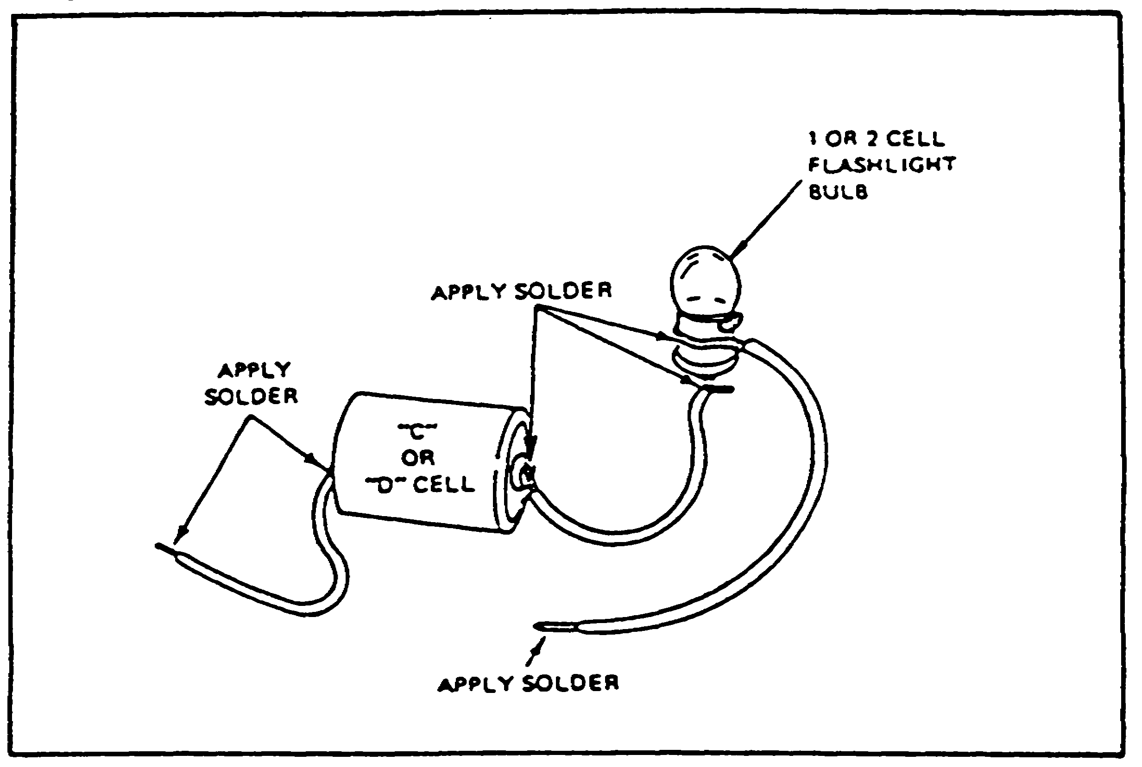

FIGURE 7. FABRICATED OHMMETER.

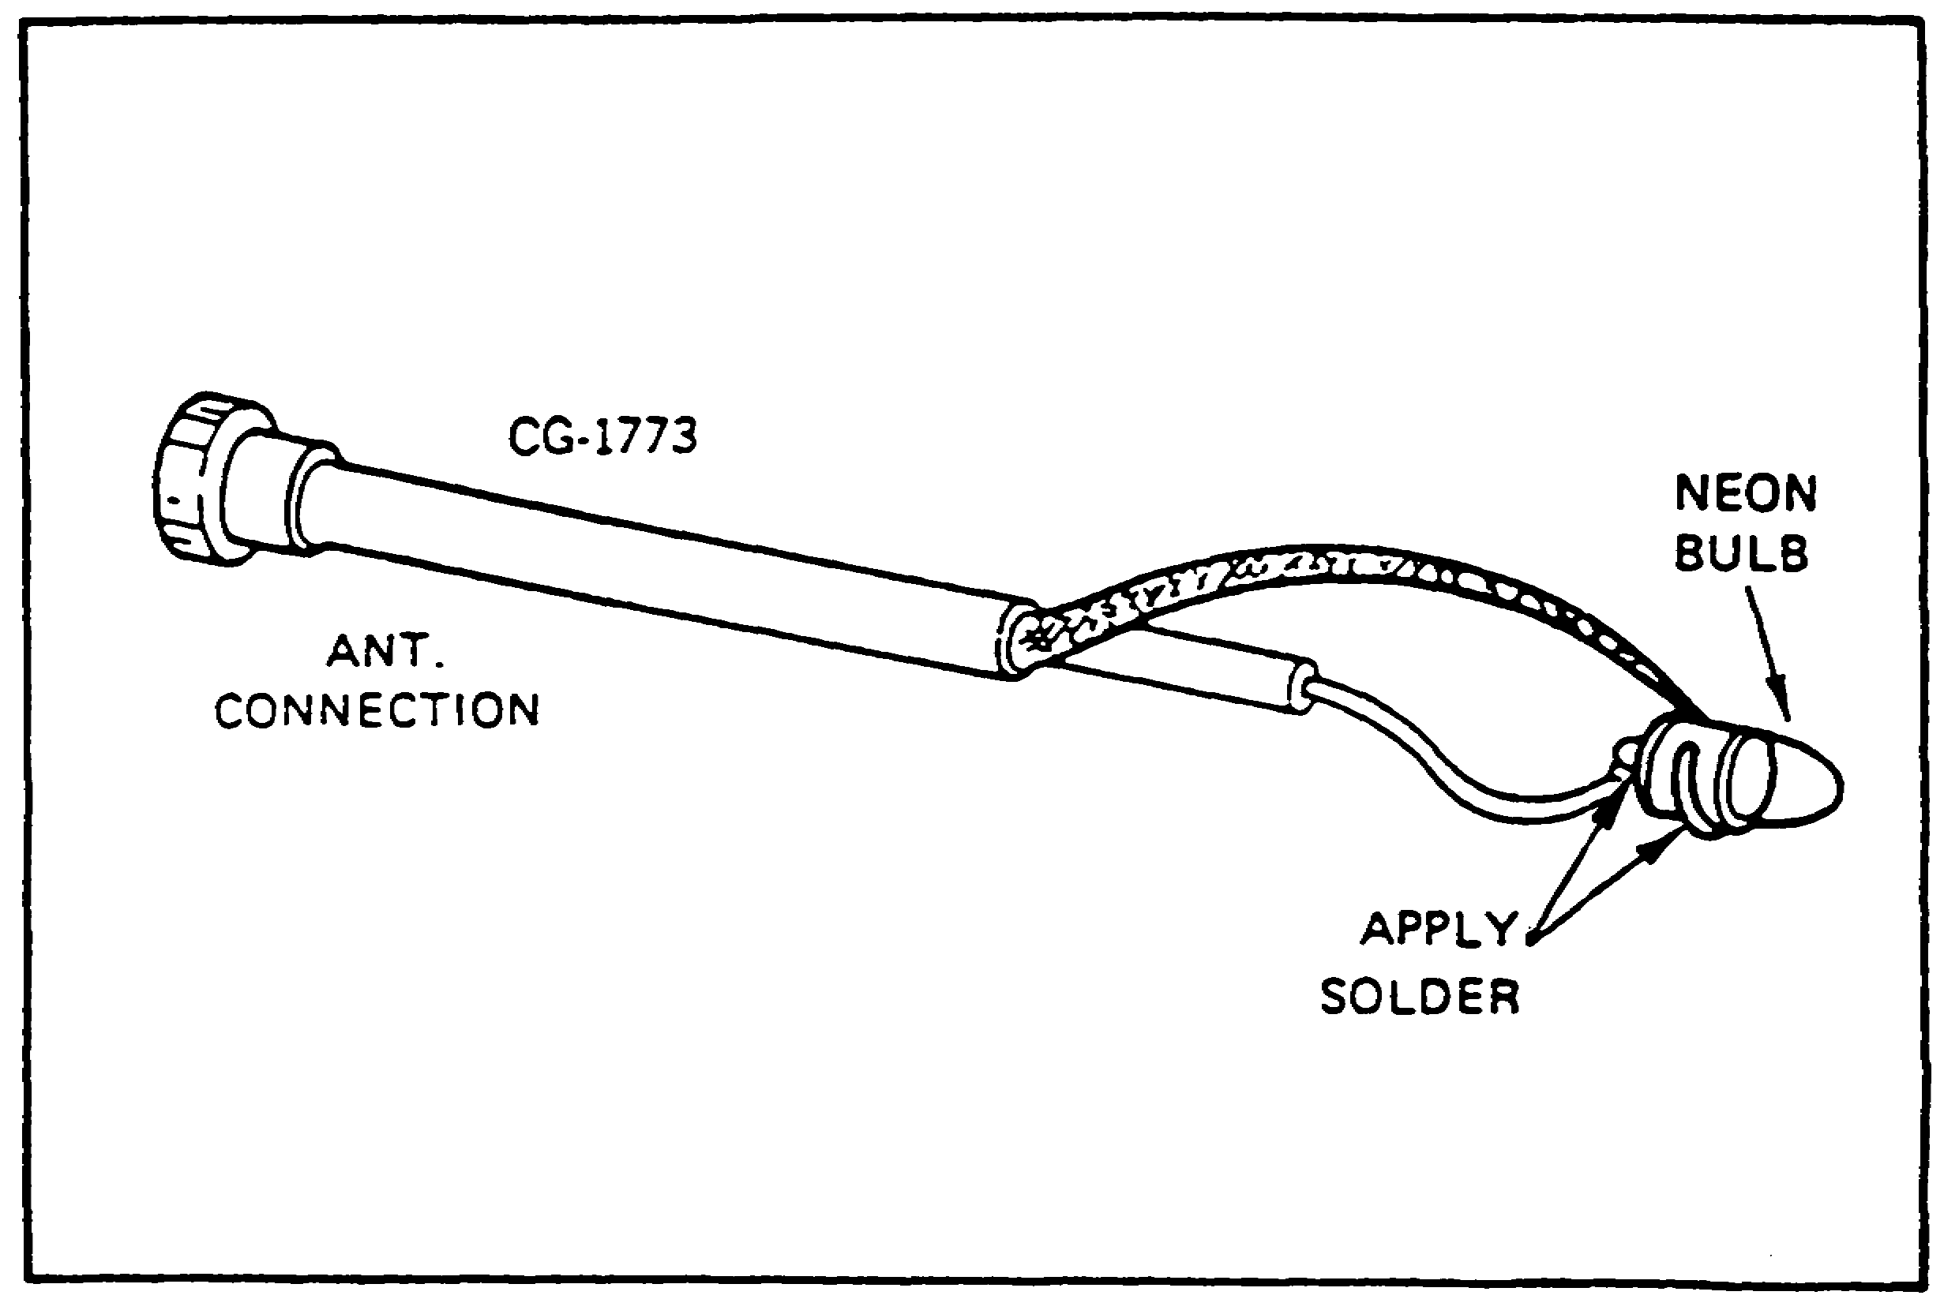

FIGURE 8. RF TRANSMITTER OUTPUT TESTER.
26

ARTILLERY BDAR - OD1512 - LESSON 1/TASK 1

(b) Test the antenna output by holding the tester vertically and moving it toward the antenna, watching the diode as the radio is keyed. Do not move the diode too close to the antenna as the diode will burn out. The diode light will give an indication of signal strength. The brighter the light, the stronger the signal.

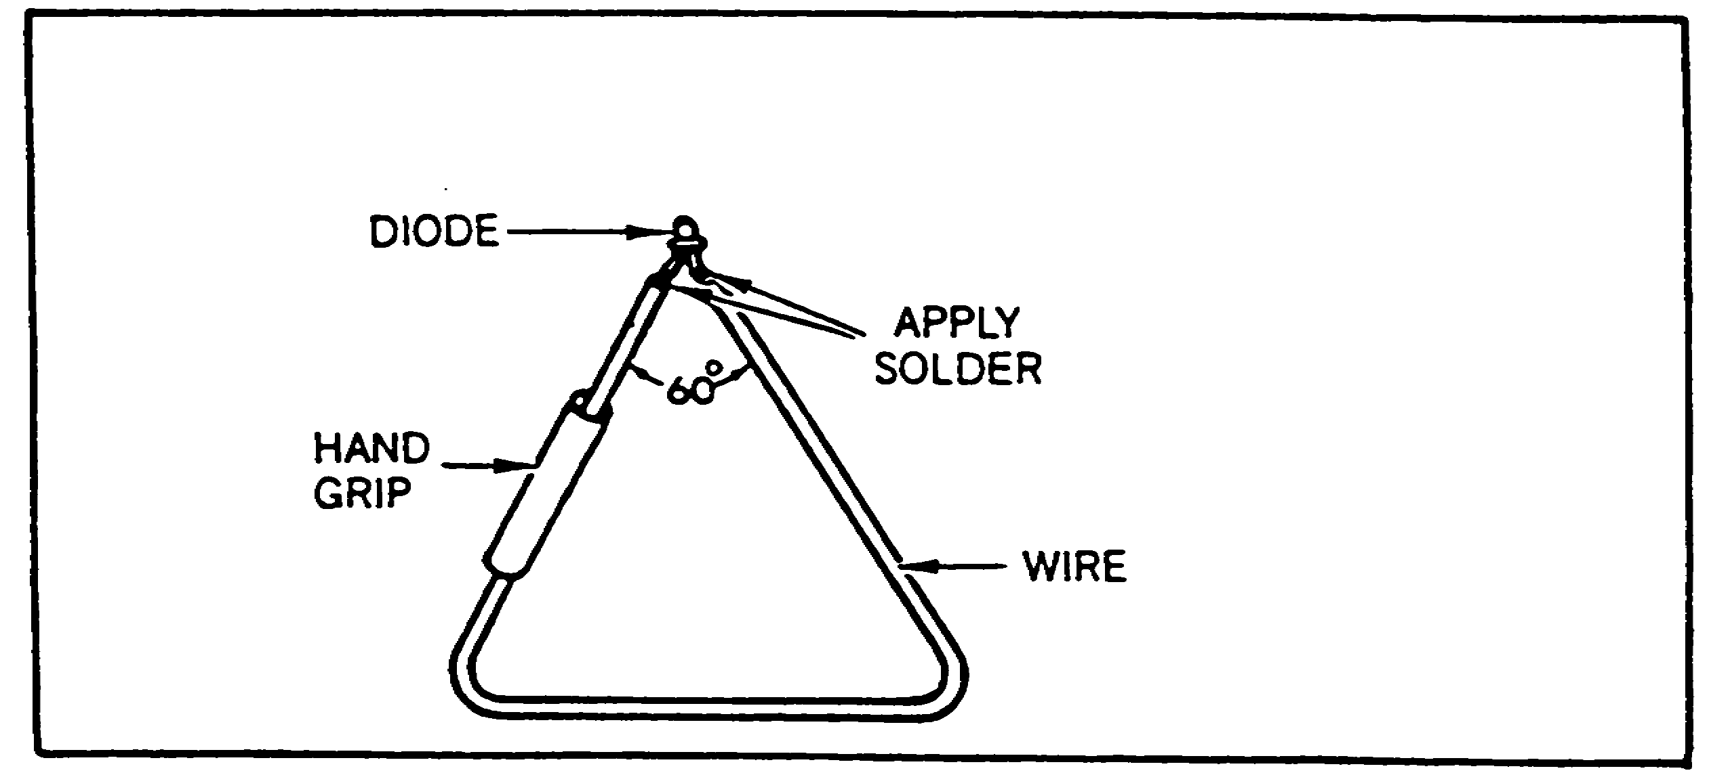

FIGURE 9. ANTENNA OUTPUT TESTER.

8. Conclusion

This task provided the necessary information for assessing battlefield damaged artillery through the use of vehicle/system assessment, battlefield damage assessment and repair forms, and test equipment. The next task will describe the repair procedures used when a battlefield damaged vehicle has been assessed to have specific problems.

27

ARTILLERY BDAR - OD1512 - LESSON 1/TASK 2

LESSON 1

ASSESSING AND REPAIRING BATTLEFIELD
DAMAGED ARTILLERY

TASK 2. Describe the procedures for repairing battlefield damaged artillery.

CONDITIONS

Within a self-study environment and given the subcourse text, without assistance.

STANDARDS

Within three hours

REFERENCES

No supplementary references are needed for this task.

1. Introduction

The procedures provided in this task are examples of those designed for battlefield environments and they should be used in situations where standard maintenance procedures are impractical. These procedures are not meant to replace standard maintenance practices, but rather to supplement them strictly in a battlefield environment. Standard maintenance procedures will provide the most effective means of returning a damaged vehicle to ready status, provided that adequate time, replacement parts, and necessary tools are available. BDAR procedures are only authorized for use in an emergency situation in a battlefield environment, and only at the direction of the commander.

2. Standards and Practices of Battlefield Damage Assessment and Repair (BDAR)

a. BDAR Characteristics. BDAR capability requires simplicity, speed, and effectiveness. Some BDAR

28

ARTILLERY BDAR - OD1512 - LESSON 1/TASK 2

procedures include repair techniques that violate standard peacetime maintenance practices. In a combat emergency situation, greater risks are necessary and acceptable.

b. Training. The unit commander should ensure that an adequate number of members of his organization, including supervisors, are trained in BDAR procedures applicable to his equipment. Each vehicle crewman should be trained to perform initial battle damage assessment for his crew position.

c. Waiver of Precautions. Under combat conditions, BDAR may be performed on artillery vehicles which are fueled and/or armed. Other similar precautions may be waived at the discretion of the commander.

d. Environment. BDAR may be required in a chemically toxic environment or under other adverse conditions with severe limitations in personnel, facilities, equipment, and materiels. Performance of repair tasks may be necessary while wearing protective gear.

e. Serviceability and Operability (Operating Characteristics). The minimum functional combat capability (MFCC) criteria for the artillery vehicles, specifically M109 howitzers, are as follows:

NOTE

These criteria may be waived for recovery or if the tactical situation demands otherwise.

(1) Armament and Fire Control.

(a) Turret must traverse 360 degrees and elevate, with no oscillations, either manually or by power.

(b) Main gun must be capable of firing without damage to the recoil system.

(c) Must have an operational fire control device (primary or secondary).

29

ARTILLERY BDAR - OD1512 - LESSON 1/TASK 2

(2) Mobility.

(a) Must have operational track on both sides of the vehicle.

(b) May be missing roadwheels, with the following stipulations:

o May not be missing more than a total of three individual roadwheels on each side.

o The first, second, and last roadwheel stations must each have complete sets of roadwheels.

o There must be a complete set of roadwheels between any two incomplete roadwheel stations.

(c) Drive train must be functional and must be capable of reverse and at least one forward gear.

(d) Power train performance degradation cannot exceed that level which would cause the vehicle to be incapable of traveling 10 miles per hour on a level, unimproved road.

(3). Communications. Must have intercom between vehicle commander and driver.

f. Permanent Repair. Upon completion of the mission, or at the next practicable opportunity, the vehicle will be recovered or evacuated to the appropriate maintenance facility for permanent standard repair as required.

3. Responsibilities and Tasks Battlefield Damage Assessment and Repair (BDAR)

a. General. Battlefield damage assessment and repair procedures are applicable at all levels from crew through intermediate general support maintenance, depending on the extent of the damage, the time available, the skills required, and the parts, components, tools, and materials available. Within these limits, each maintenance level will rapidly take whatever action is necessary to restore the vehicle to the combat ready condition required for continuation of the mission. Battlefield damage repair kits, consisting of essential tools, may be carried onboard each vehicle to enable the crew to rapidly fix the simplest and most common types of damage/failure.

30

ARTILLERY BDAR - OD1512 - LESSON 1/TASK 2

b. Commander and Crew. The crew of the damaged vehicle will make the first assessment immediately after damage has occurred. Crew members will provide the vehicle commander with an initial damage assessment which will include notice of system failure and all major vehicle systems visibly damaged, inoperative or impaired. If possible, all systems will be checked at the same time by different crew members. If the failure is due to hostile fire, the report will include the location of impact and the manning status. Immediacy of the report is more important than how long it will take to get back into action. The initial report, therefore, may omit repair time estimates. The vehicle commander must make an initial out-of-action report to the executive officer's post, including these essentials:

(1) Vehicle damaged (out-of-action or impaired).

(2) Location of vehicle.

(3) Firepower status.

(4) Mobility status.

(5) Manning status.

(6) Current and anticipated enemy action.

If communication capability is damaged, the vehicle commander should approach the nearest friendly radio and make his report.

In a forward battle area it is imperative that the crew attempt to move the vehicle to a covered or concealed position to prevent additional combat damage. This is the first priority. If the vehicle is not capable of self-movement, use any vehicle, including other combat vehicles to recover the vehicle or to get concealment. If this is not possible, then the turret should be turned in the direction of engaging fires in order to limit damage and possibly return fire.

A safety check should be made for any obvious hazards.

o Is there an ammunition round in the tube?

o Are any ammunition rounds critical due to shock, fire, or physical damage?

31

ARTILLERY BDAR - OD1512 - LESSON 1/TASK 2

o Have any combustibles such as fuel, hydraulic fluid, or oil accumulated?

o Does wiring appear to be safe? Could arcing occur near stored ammo or leaking combustibles?

o Is the fire extinguishing system operational? If not, then one crew member should be stationed in the turret, either with a hand fire extinguisher or prepared to manually operate the turret fire extinguisher. A second crew member should be stationed outside the turret with the other fire extinguisher. He should also be prepared to manually actuate the engine compartment fire extinguisher.

A functional/operational test should be performed next on those systems which appear undamaged. For systems with a built-in self-test feature, this will be used. Only those systems found to be damaged or inoperative, shall be identified.

The vehicle commander shall report to the executive officer's post the results of the crew's damage assessment, naming the major known causes of the vehicle's immobility and/or lack of firepower. If repair by crew is possible, he shall report a total estimated repair time and what functions may be restored.

The executive officer's post will respond with directives and, if required, will call a maintenance team (MT) to the location of the damaged vehicle for assistance. If possible, sufficient information will be provided to enable the MT to bring any needed repair parts or special tools.

The crew shall proceed to make any possible field expedient repairs to restore firepower, communications and/or vehicle mobility within the limits of skills, materials, and tools available.

c. Unit Maintenance and Maintenance Teams (MTs). The unit maintenance team (MT) and assessor operate out of the battery or battalion trains. The MT assessor performs his assessment and the maintenance team completes repairs, if possible, at the damage site. If the site is within direct fire or under enemy observation, movement to a more secure site in defilade may be necessary. This is still considered "on-site".

32

ARTILLERY BDAR - OD1512 - LESSON 1/TASK 2

If the vehicle has been left unattended in the forward battle area, the immediate area of the vehicle should be checked for mines and the vehicle should be checked for booby traps before starting the battle damage assessment.

The MT assessment will be more thorough than the crew's, using unit maintenance support tools and equipment as needed. MT assessment includes:

o Reviewing the crew's out-of-action report, if available.

o Interviewing commander and crew, if available.

o Visually inspecting damaged parts and systems.

o Performing a self-test.

o Making tests with organizational test equipment, if required.

o Performing additional vehicle operational tests, as necessary.

Using this information and following the damage assessment steps, the MT will:

o Determine what must be repaired or replaced.

o Determine sequence and priority of repair actions.

o Estimate repair times for each repair task.

o Total the repair task times and determine if the repairs can be performed in the time available.

o Determine repair location and, if other than on-site, arrange for recovery of the vehicle to the repair site.

If all critical repairs can be made within the available time with the skills, materials, tools, and equipment at hand, the MT, assisted by the crew, will proceed with the on-site repair.

33

ARTILLERY BDAR - OD1512 - LESSON 1/TASK 2

If the damage exceeds the repair capability of the MT, and time is available for a MST on-site fix, the MST shall be called.

If time for a MST on-site fix is not available, but the vehicle is repairable, the MT shall provide for recovery of the vehicle to a designated collection point.

If the vehicle is not repairable, the MT shall provide for one of the following:

o Recovery to a maintenance collection point for evacuation to the rear.

o On-site stripping (if approved by commander and coordinated with support maintenance).

o Abandonment/destruction (if directed by commander).

Vehicle hulls should never be abandoned if recovery/evacuation is possible because hulls can almost always be rebuilt, no matter how badly damaged they are. If the vehicle is damaged catastrophically and evacuation is not possible, remove items in the following order:

o Needed spares on-site.

o Sensitive, high value, limited size items.

o Other needed spares or repair parts.

If the vehicle is contaminated, the MT shall mark the vehicle with contamination markers and arrange for recovery to a decontamination site.

d. Intermediate Direct Support/Intermediate General Support (IDS/IGS) Maintenance Team. The MST shall assist the MT as needed, using intermediate direct support maintenance tools and equipment. MST assessment and repair procedures are the same as those of the MT except at a higher maintenance level. If possible, the MT will tell the MST what tools and spare parts are needed to perform the repairs. While waiting for the MST to arrive, the crew, under the supervision of the MT, will open up the vehicle and make it ready for the MST to perform BDAR when it arrives.

34

ARTILLERY BDAR - OD1512 - LESSON 1/TASK 2

Damaged vehicles removed to designated repair sites shall be selected for repair by the MST in order of:

o Most essential to the completion of the mission.

o Can be repaired in the least amount of time.

e. Time Limits for Repairing Damage. In combat, the time available for BDAR is limited. One of the factors to be considered in the selection of a repair site is the amount of time available at the site based on the tactical situation. Every assessment must include an estimate of total elapsed time for all tasks required to restore the vehicle. The time available at the selected repair site must equal or exceed the estimated time required to accomplish all tasks associated with the BDAR.

Determining where BDAR will take place should be based on the guidelines in Table 2 on the following page. These are general rules which must be adjusted by the commander, based on his best estimate of how the most responsive maintenance support can be provided. He must consider tactical situation, maintenance backlog, personnel, tools, test, measurement and diagnostic equipment (TMDE), and repair parts available. The guidelines are based on a defensive scenario and can be extended when applied to the offense.

f. Recording BDAR Repairs. All components of an artillery vehicle, which are repaired using BDAR or other expedient techniques, shall be marked with a tag, DD Form 1577, or similar conspicuous tag. It is not necessary to fill out the form. The purpose of identifying an item which has been repaired using BDAR techniques is to quickly enable mechanics to quickly recognize these parts when the vehicle is subsequently returned for authorized permanent repair.

Since it is impractical to attach tags to expediently repaired components located on the outside of the vehicle, the fix shall be noted on DD Form 1577 or similar tag, and the tags stored in the compartment normally reserved for the vehicle log book.

35

ARTILLERY BDAR - OD1512 - LESSON 1/TASK 2

TABLE 2. SUMMARY OF BDAR TIME GUIDELINES.

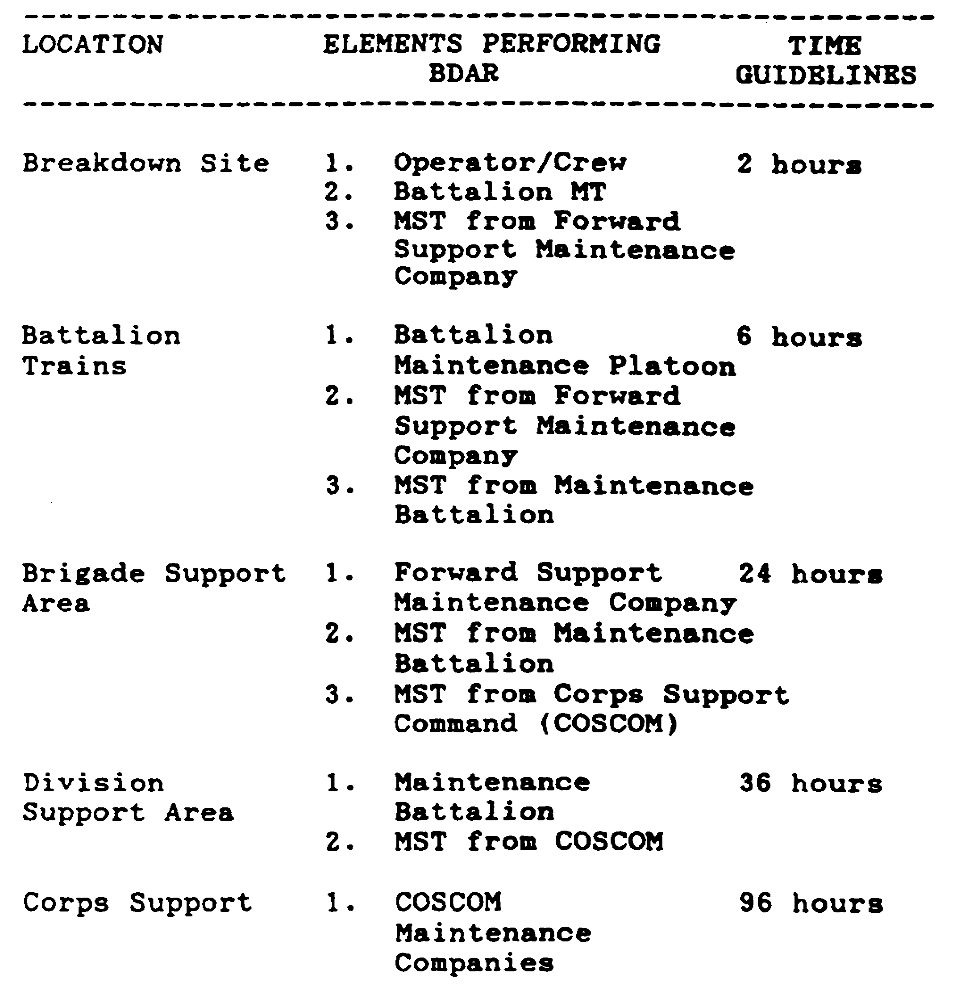

A tag should also be placed conspicuously in the vehicle commander's position when a BDAR procedure has resulted in a degraded operating capability. This tag should be marked "BDAR" and noted with its specific limitations or cautions.

When a component is cannibalized from a repairable vehicle, a tag should be attached in the space created by the missing part to alert downstream repair personnel quickly that the part has been removed.

When the vehicle is recovered/evacuated for permanent standard repair, and DA Forms 2404 and

36

ARTILLERY BDAR - OD1512 - LESSON 1/TASK 2

2407 are used, the notation "BDAR" shall be added in the space provided for the description of deficiencies.

4. Battlefield Damage Assessment and Repair (BDAR) Procedures

a. General. This paragraph will provide examples of expedient repair procedures for six individual systems on an artillery vehicle. These systems are the fuel supply system, cooling system, electrical system, track and suspension, engine, and hydraulic power distribution. Three expedient procedures for these systems provide options for repairing and/or replacement that may be used depending on the circumstance.

b. Fuel Supply Systems. Fuel supply systems consist of fuel storage tanks, fuel pumps, filters, and the tubes and hoses needed to route the fuel to the engine. Some systems use electrical fuel pumps located in the tanks and a mechanized engine-mounted fuel pump to move the fuel. Other systems mount the fuel storage tank in a location which allows gravity flow of the fuel to the engine, assisted by an engine mounted mechanized pump. Two filters are mounted in series to provide a primary and secondary filtration system to trap dirt and other contaminants. Fuel filters must be checked for accumulations of dirt and water. A diesel engine can be severely damaged by using unfiltered fuels.

(1) Fuel Storage Systems. Fuel storage systems may be enclosed metal containers, nylon fiberglass tanks, or rubber re-enforced fuel bladders installed in vehicle bulkheads. All systems are susceptible to contamination from dirt or water. Metal tanks are susceptible to corrosion which will contaminate the stored fuel. Draining and purging fuel tanks of contaminants are of major importance for long combat usage. Leakages caused by normal vibration or actual combat induced damage must be repaired before the vehicle can be used for combat.

(a) Fuel Tank Leaks. Fuel tank leaks are difficult to repair in a battlefield environment. Combat vehicle fuel tanks are normally obstructed by the powerpack or other major assembly. The repairs are also dictated by the type of material from which the fuel tank, cell, or fuel bladder is manufactured. Fuel leakage is an indication that a

37

ARTILLERY BDAR - OD1512 - LESSON 1/TASK 2

fuel storage container is damaged. Time required for repairs will vary with the fuel tank location and ease of access for repairs. The area surrounding the damage must be cleaned to make a good repair. Heat will hasten curing of fiberglass or epoxies.

There are three options for repairing fuel tank leaks. Options 1 and 2 are for repairing aluminum and fiberglass fuel tanks, respectively, and option 3 is for plugging holes on either the aluminum or fiberglass tanks. These options are as follows:

OPTION 1: ALUMINUM FUEL TANKS.

Limitations: None, if welded

Personnel/Time Required: 1-3 soldiers/2-6 hours

Materials/Tools: Welding equipment, aluminum scrap, rivets or screws

Other Options: Use fiberglass repair or plug Procedural Steps:

STEP 1. Gain access to the damaged area on the fuel tank.

STEP 2. Drain and vent fuel tank. (Purge the tank using vehicle exhaust gases.)

STEP 3. Cut an aluminum patch large enough to extend 1-2 inches over the hole edges.

STEP 4. Attach the patch to the tank. If available, metal inert gas (TIG) or tungsten inert gas (TIG) weld the patch to the fuel tank. If welding equipment is not available, drill holes in patch and tank approximately one inch apart. Apply sealer to the patch and rivet or screw the plate to the fuel tank, as shown in figure 10 on the following page.

STEP 5. Reinstall fuel tank, if removed.

OPTION 2: FIBERGLASS FUEL TANKS.

Limitations: None, if fiberglass kit is used

Personnel/Time Required: 1-3 soldiers/2-6 hours

38

ARTILLERY BDAR - OD1512 - LESSON 1/TASK 2

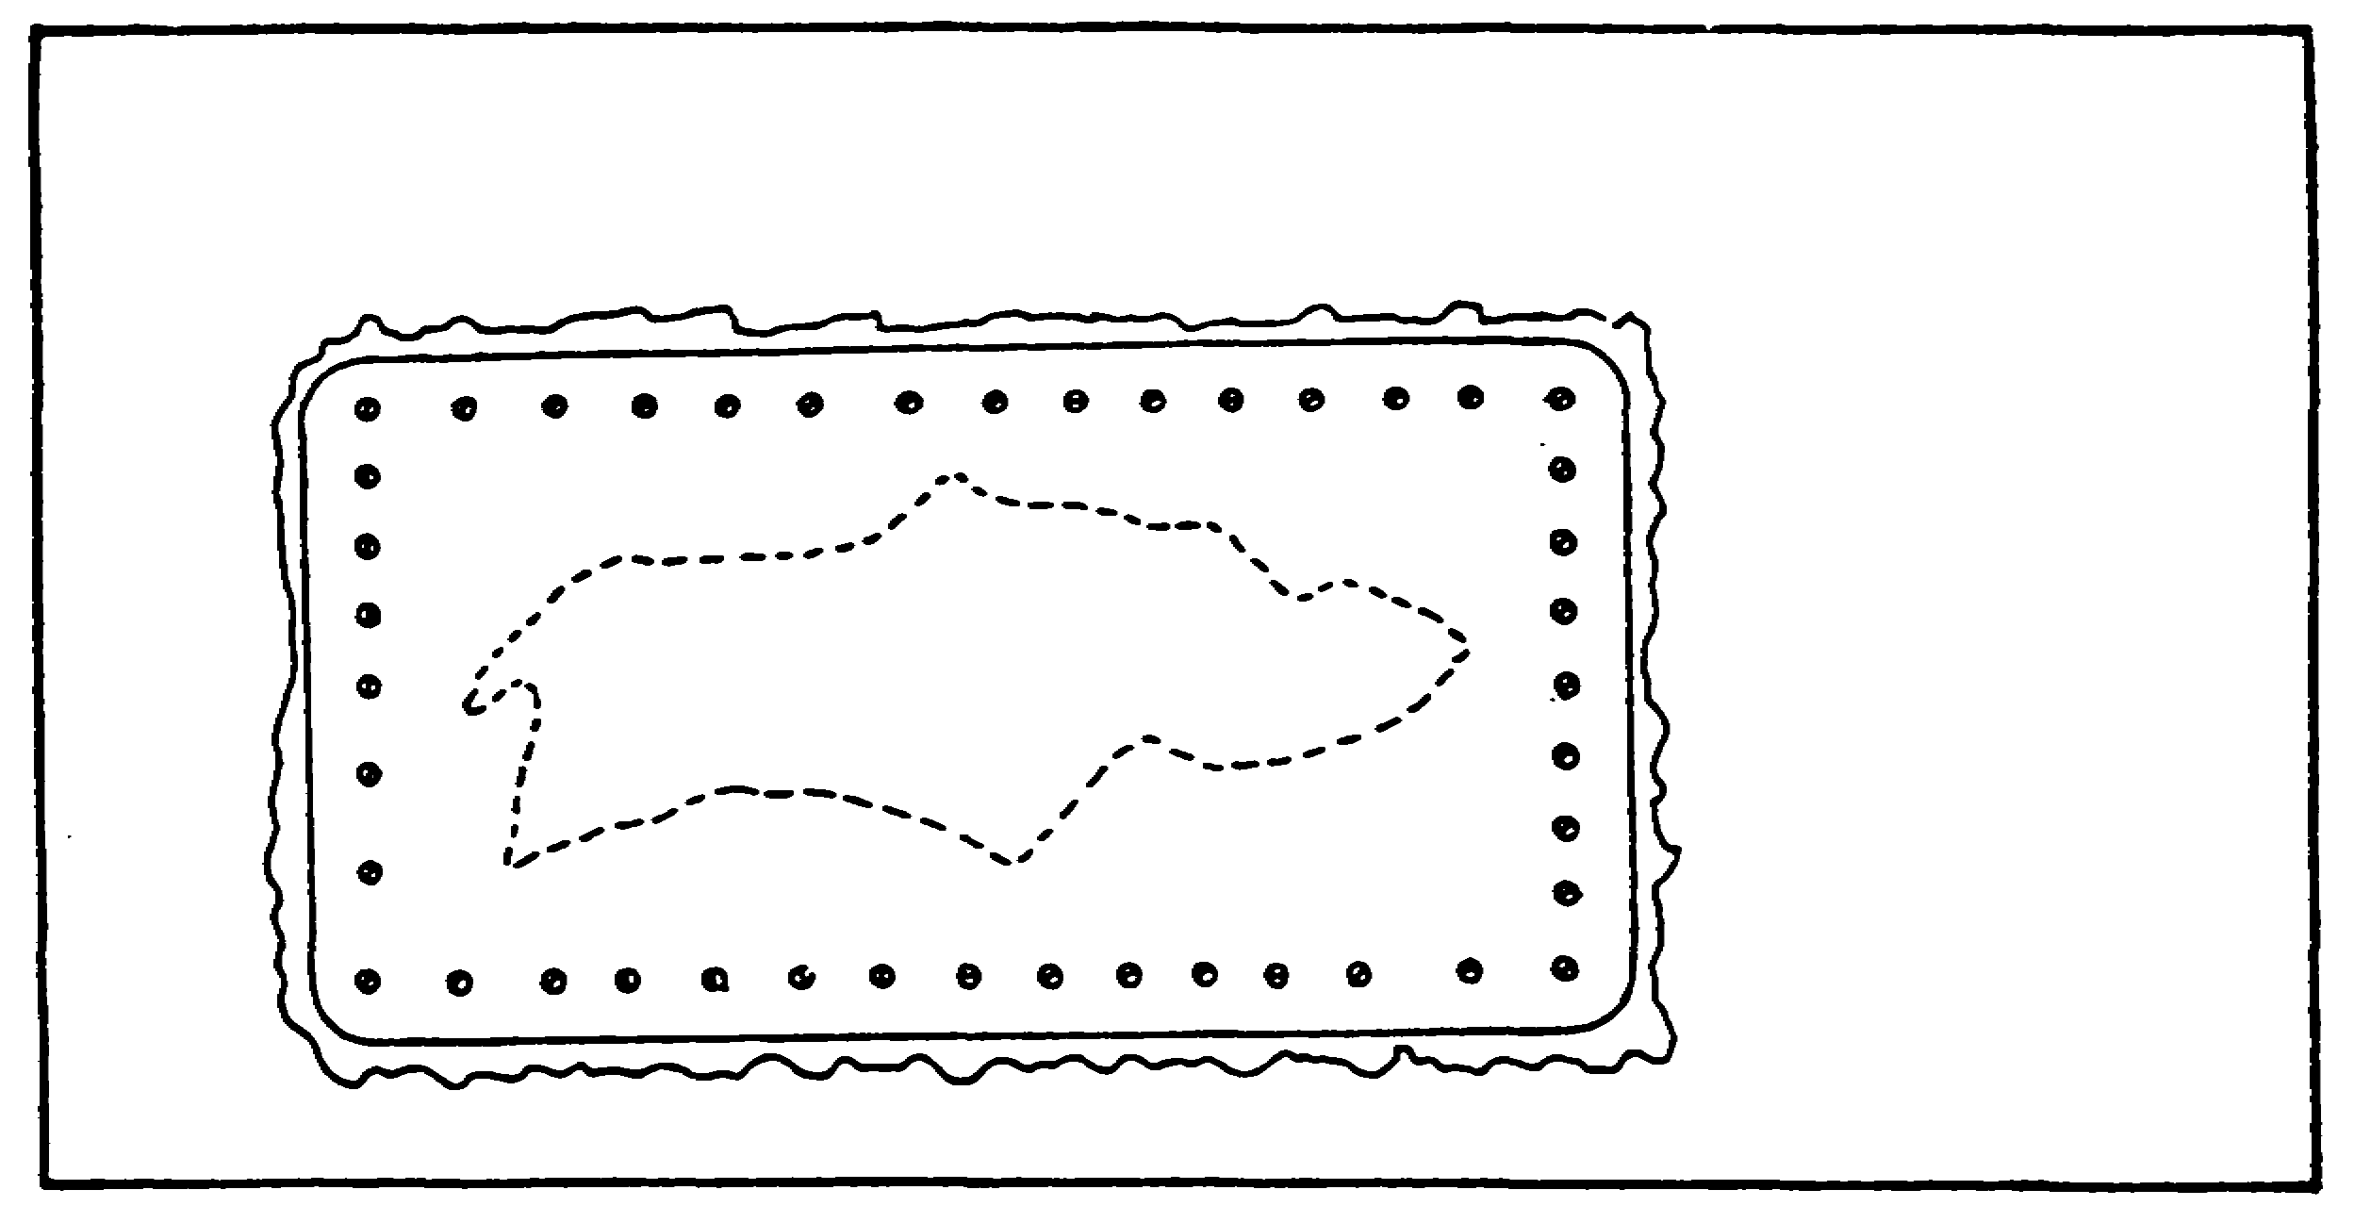

FIGURE 10. RIVETING OR SCREWING PATCH
TO FUEL TANK.

Materials/Tools Required: Epoxy, fiberglass repair kit, gasket sealer, pop-rivets

Other Options: Plug hole

Procedural Steps:

STEP 1. Gain access to fuel tank.

STEP 2. Drain fuel tank.

STEP 3. Clean oil and fuel residue from damaged area.

STEP 4. Rough up area around damage with sandpaper or a file.

STEP 5. Repair using one of the following methods:

o Apply fiberglass following kit instructions.

o Mix and apply epoxy following kit instructions.

o Cut sheet metal patch, drill tank and patch, coat patch liberally with fuel resistant gasket sealer. Attach patch with pop-rivets, seal rivet heads with sealer.

STEP 6. Reinstall fuel tank, if removed.

39

ARTILLERY BDAR - OD1512 - LESSON 1/TASK 2

OPTION 3: PLUGGING HOLES, METAL OR FIBERGLASS TANKS.

Limitations: None

Personnel/Time Required: 1-3 soldiers/1-3 hours

Materials/Tools: Rubber hose, bolt and nut, two (2) large flat washers

Other Options: Use fiberglass or epoxy

Procedural Steps:

STEP 1. Gain access to fuel tank hole.

STEP 2. Drain fuel until level is below the hole.

STEP 3. Obtain hose the approximate size of the hole.

STEP 4. Using a round file, file the hole to a size equal to the hose diameter.

STEP 5. Assemble the hose, bolt, nut and washers as shown in figure 11 on the following page.

STEP 6. Coat the hose assembly with sealer to aid in the repair.

STEP 7. Insert the hose assembly into the hole.

STEP 8. Tighten the bolt and nut to make the hose expand and seal the fuel tank hole.

STEP 9. Reinstall the fuel tank, if removed.

At the completion of the above options, the BDAR action taken should be recorded. When the mission is completed, or as soon as practicable, repair the vehicle using standard maintenance procedures.

c. Cooling System. Cooling system problems may be indicated by a variety of faults. Typically the driver's indicator panel will show overheating.

(1) Liquid Cooling System. During performance of repairs or as a result of leakage, the coolant may become lost. A liquid cooled engine cannot operate for long without coolant. When normal coolants are not available, a substitute may be used. Any liquid, except gasoline or jet fuels,

40

ARTILLERY BDAR - OD1512 - LESSON 1/TASK 2

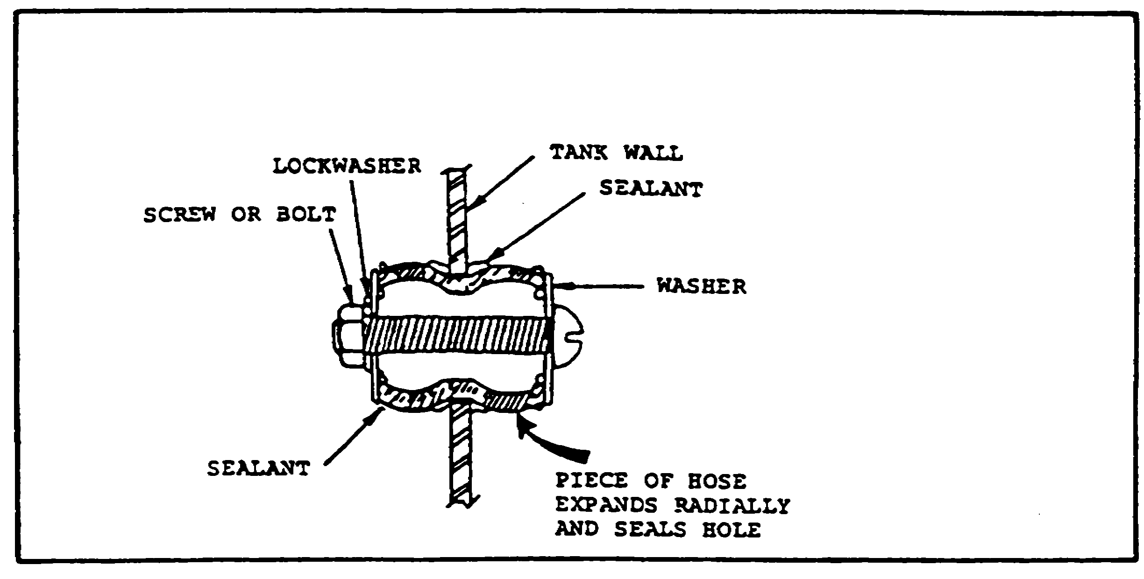

FIGURE 11. ASSEMBLY OF HOSE, BOLT,
NUT AND WASHERS.

can be used as a substitute but some liquids will deteriorate the cooling system rubber components.

Petroleum products will not transfer the heat as efficiently as a water-based coolant, but will work if nothing else is available. Old engine oil or fluids drained from damaged vehicles, transmission oil, hydraulic systems, may be a possible source of fluids. The cooling system must be drained and flushed as soon as possible if petroleum-based fluids are used.

(a) Radiator Leaking. Radiator leaking may be detected by low coolant levels. Obvious wet areas or overheating will indicate that the coolant level must be checked. The repair procedure used is dependent on the size of the hole(s) causing the leak. The following procedures provide options to stop or reduce the leakage rate. These options are for small hole leaks, tubing to heater joint leaks, and core puncture leaks.

OPTION 1: SMALL HOLE LEAKS.

Limitations: None

Personnel/Time Required: 1 soldier/15-30 minutes

Material/Tools: Stop leak chemical, cigarette or tobacco, pepper, eggs, oatmeal, farina (cream of wheat), cornmeal

41

ARTILLERY BDAR - OD1512 - LESSON 1/TASK 2

Procedural Steps:

STEP 1. Remove radiator cap and start engine.

STEP 2. Add coolant to bring coolant to the proper level.

STEP 3. Sprinkle or pour one of the materials listed above into the coolant.

STEP 4. Inspect the hole for evidence of reduced or eliminated leakage.

STEP 5. Add more material if leak has not stopped or been reduced to an acceptable limit.

STEP 6. Leave radiator cap loose.

STEP 7. Plug overflow lines on surge tank equipped coolant systems (M109 S.P. howitzer family) as shown in figure 12 on the following page.

OPTION 2: TUBING TO HEATER JOINT LEAKS.

Limitations: None

Personnel/Time Required: 1 soldier/1-4 hours

Material/Tools: Wire brush, solvent, epoxy

Procedural Steps:

STEP 1. Gain access to radiator.

STEP 2. Inspect the radiator and pinpoint the leak location.

STEP 3. Drain the coolant.

STEP 4. Clean the leak area with solvent or available cleaner.

STEP 5. Scrape or rough up the damaged surface with a wire brush or knife as illustrated in figure 13 on the following page.

STEP 6. Mix epoxy according to kit instructions and fill the hole with the mixture. Work the epoxy well into the crack.

42

ARTILLERY BDAR - OD1512 - LESSON 1/TASK 2

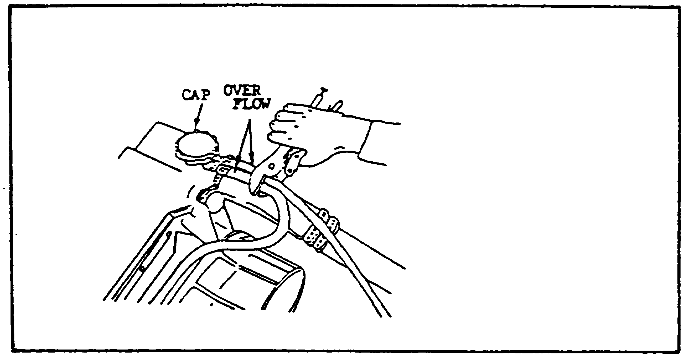

FIGURE 12. PLUGGING OVERFLOW LINES.

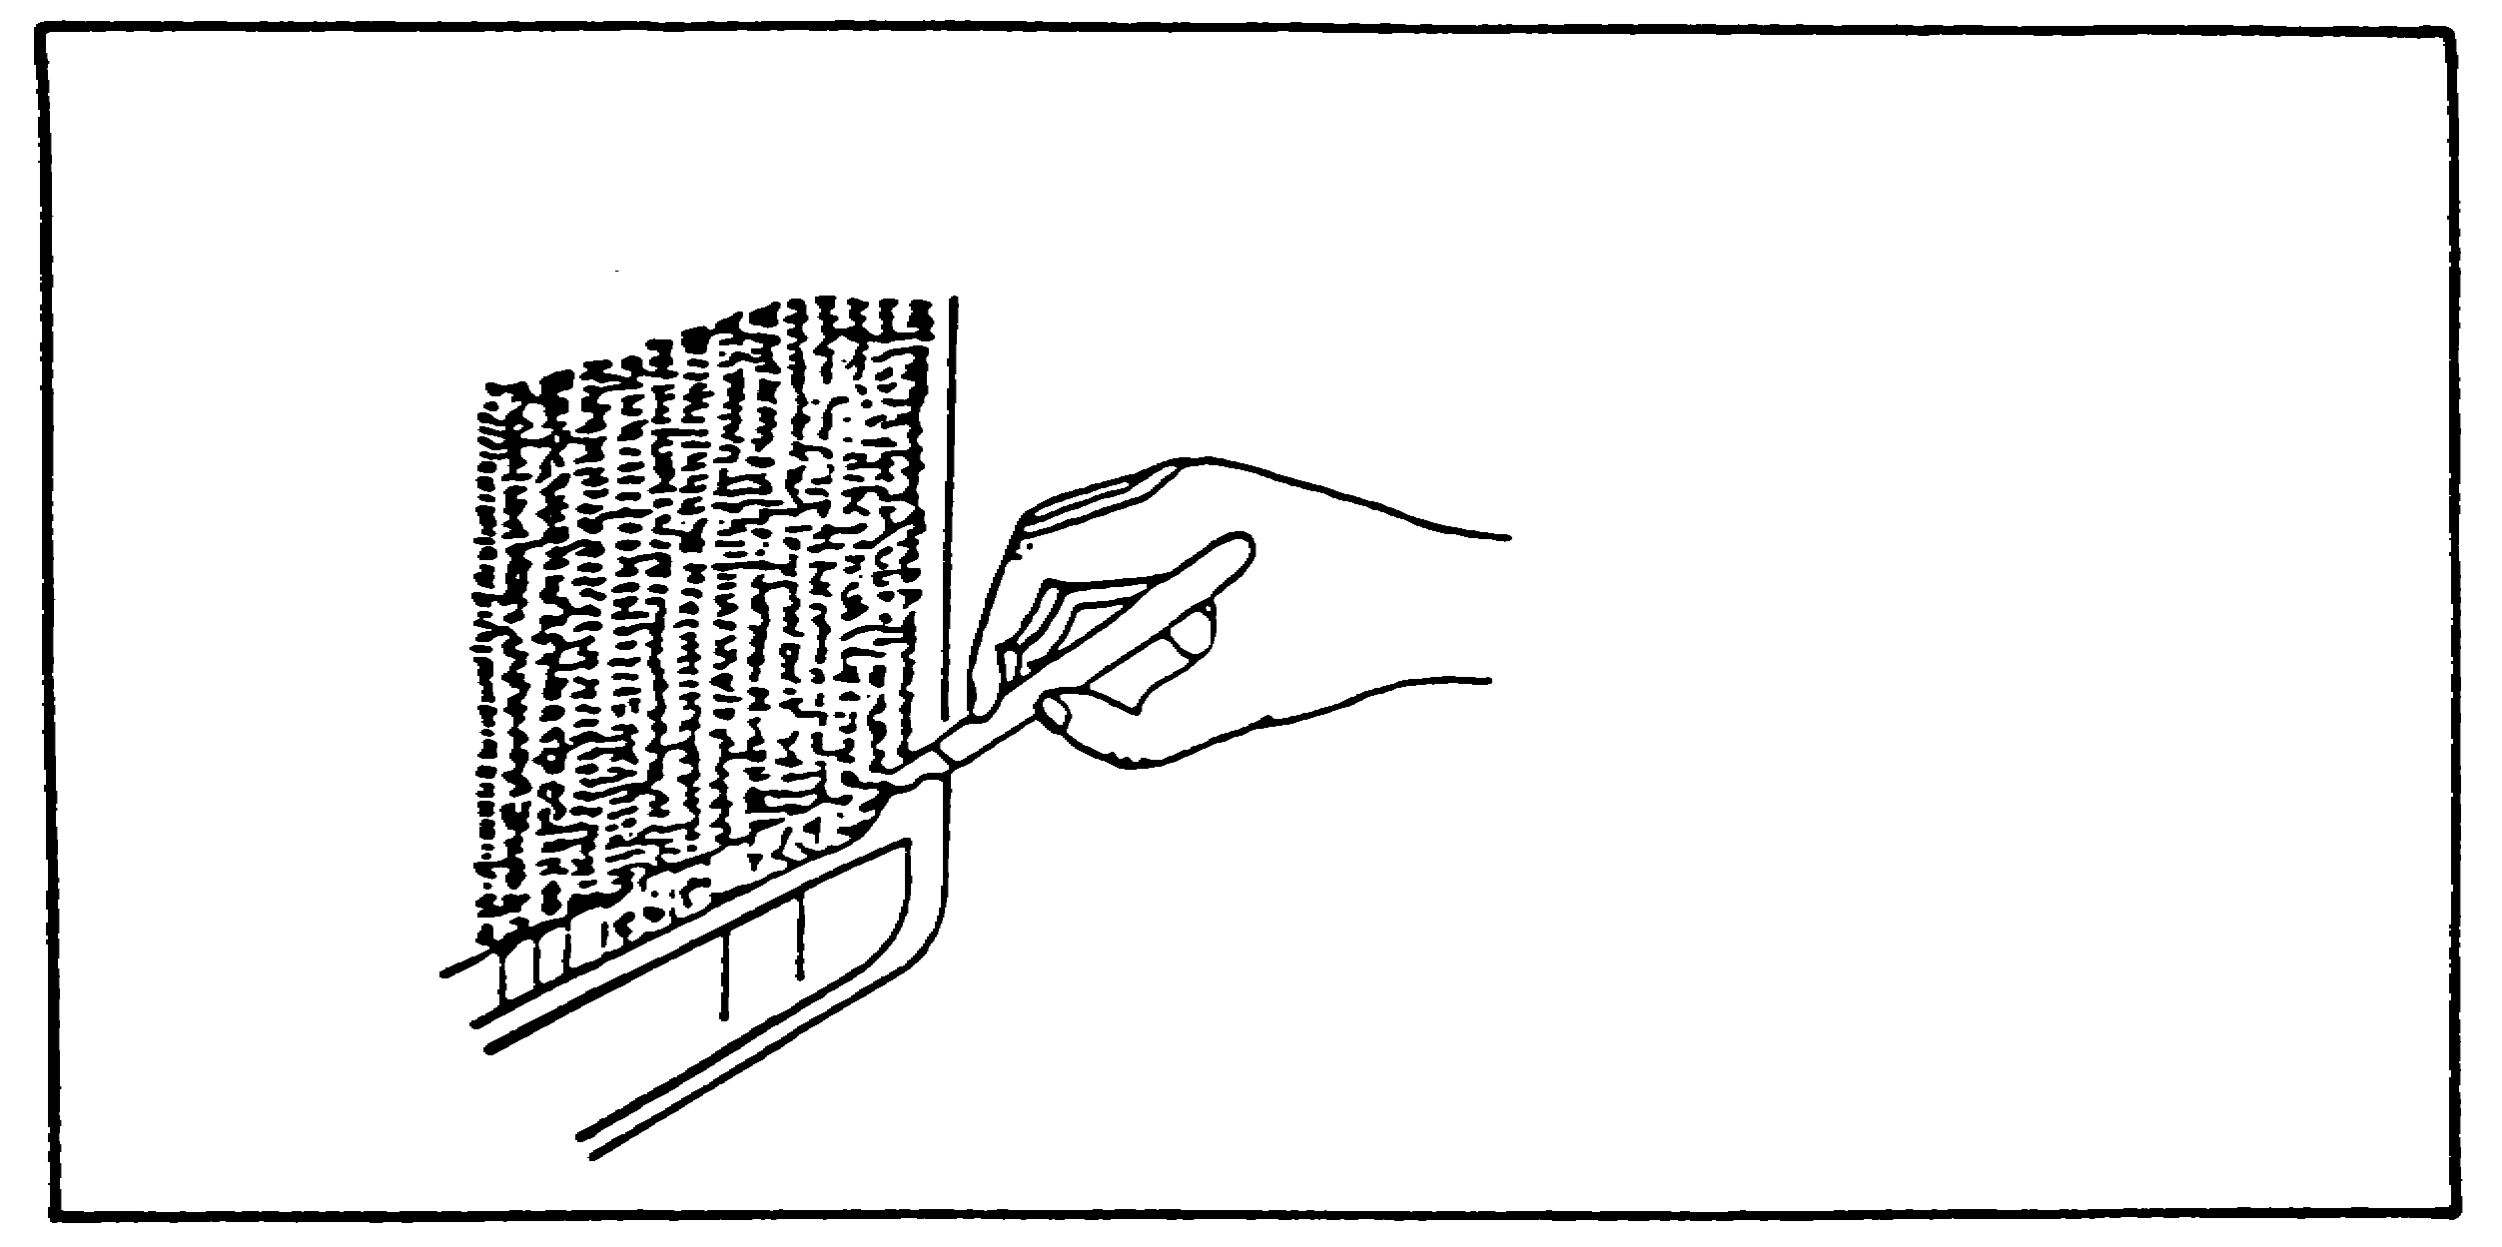

FIGURE 13. SCRAPING DAMAGED SURFACE
OF RADIATOR.

STEP 7. Allow epoxy to cure. A heat lamp will speed the curing.

STEP 8. Reinstall coolant and check for leaks.

OPTION 3: CORE PUNCTURED LEAKS.

Limitations: Possible reduced cooling

43

ARTILLERY BDAR - OD1512 - LESSON 1/TASK 2

Personnel/Time Required: 1 soldier/30-60 minutes

Materials/Tools: Side cutters, epoxy or solder

Procedural Steps:

STEP 1. Gain access to radiator.

STEP 2. Inspect the radiator to pinpoint the leak location.

STEP 3. Drain the coolant.

STEP 4. Using side cutters, cut or break away the cooling fins from the coolant tubes, 1 to 2 inches each side of the leak.

STEP 5. Cut the coolant tube at the leak location, taking care not to tear or puncture the other tubes.

STEP 6. Squeeze the tube ends together and fold over on itself approximately 1/2 inch (see figure 14 on the following page).

STEP 7. If epoxy or solder in available, seal the coolant tube ends.

STEP 8. If no epoxy or solder is available, fold the tube once more 1/2 inch to restrict the coolant leaks.

STEP 9. Reinstall the coolant. Inspect radiator for leaks.

At the conclusion of the preceding options, the BDAR action taken should be recorded. When the mission is completed, or as soon as practicable, repair the vehicle using standard maintenance procedures.

d. Electrical Systems. Electrical systems on combat vehicles are 24 volt negative ground, direct current systems. Electrical current storage for starting and standby circuits is provided by batteries. The batteries are connected in a series-parallel configuration to provide 24 volts direct current (vdc). All electrical power to circuits can be turned off by a main power switch.

44

ARTILLERY BDAR - OD1512 - LESSON 1/TASK 2

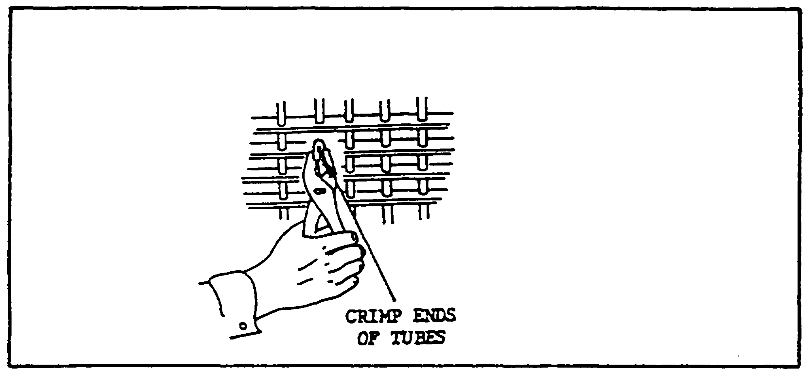

FIGURE 14. CRIMPING ENDS OF TUBES.

The main power switch prevents accidental discharge of the batteries if a subsystem is not turned off. Figure 15 on the following page shows an example of the basic vehicle electrical system.

(1) Electrical Motors. Repair on automotive motors should be restricted to relays, solenoids, and brushes. Damage to casings and winding cannot be expediently repaired.

(a) Starter Solenoid Defective, Delco-Remy Only. With uneven wear of the solenoid plunger shaft, a lip will form on one side of the shaft and the engine starter will not engage. Temporary repair can be made by removing solenoid and rotating solenoid plunger shaft 80 degrees. The procedure for repairing a defective solenoid is described in the following text:

Limitations: Starter solenoid life is shorter than new part

Personnel/Time Required: 1-3 soldiers/i-6 hours

Materials/Tools: None

Procedural Steps:

STEP 1. Disconnect power. (Unhook negative battery terminal.)

45

ARTILLERY BDAR - OD1512 - LESSON 1/TASK 2

STEP 2. Gain access to engine starter; remove if required.

STEP 3. Remove solenoid from starter (see figure 16 on the following page).

STEP 4. Rotate solenoid plunger shaft 180 degrees.

STEP 5. Install solenoid on starter.

STEP 6. Reconnect power and test starter operation.

The BDAR action taken is recorded and when the mission is completed, or as soon as practicable, the vehicle is repaired using standard maintenance procedures.

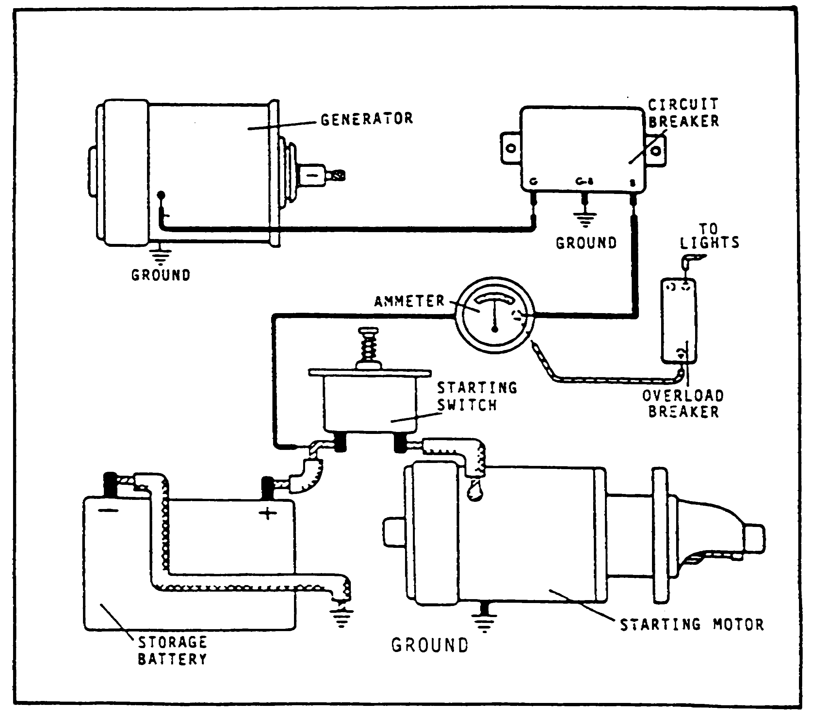

FIGURE 15. BASIC VEHICLE ELECTRICAL SYSTEM.

46

ARTILLERY BDAR - OD1512 - LESSON 1/TASK 2

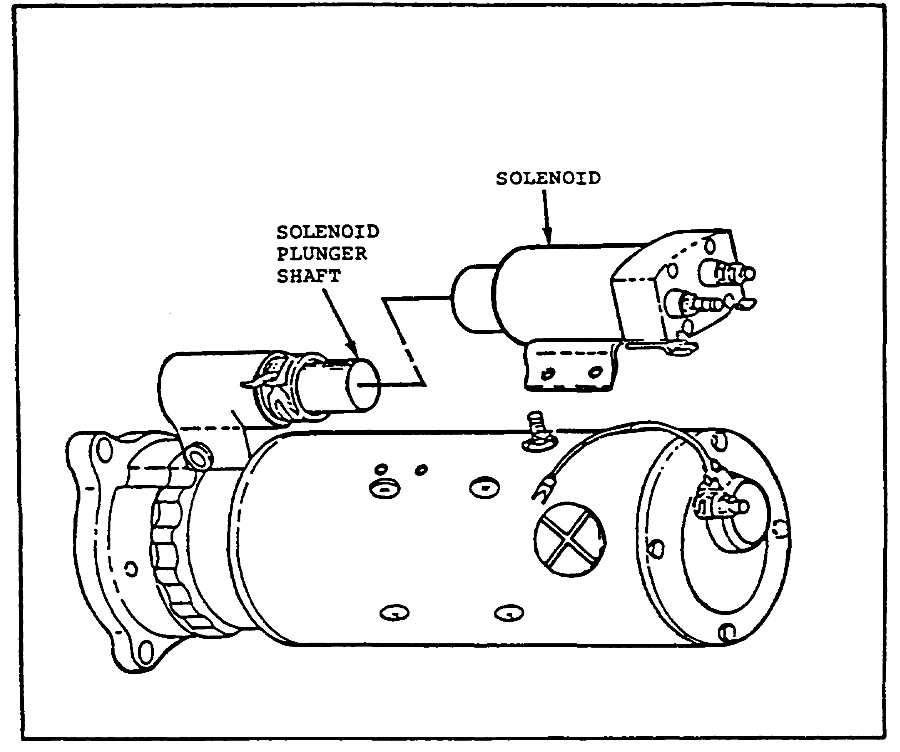

FIGURE 16. POSITION OF SOLENOID AND
SOLENOID PLUNGER SHAFT
ON STARTER MOTOR.

e. Track and Suspension. The track and suspension systems are designed to work together. When the track and/or suspension becomes damaged and no replacements are available, the track can be shortened and suspension positions can be bypassed. Some vehicles cannot be short-tracked because of hull interference which would result in the track not having enough clearance to operate. After the vehicle has been short-tracked, the major problem will be to maintain track tension. As roadwheels, arms, and torsion bars are eliminated, there will be less ground clearance and heavier loading on the remaining components. The driver must reduce speed and select the smoothest terrain possible. Vehicle operation can continue if sufficient material is left in the hull to support either the shock absorber or torsion bar housing. Many items within the suspension system are identical regardless of

47

ARTILLERY BDAR - OD1512 - LESSON 1/TASK 2

position, but some have minor differences from left to right and from front to rear. Examples of BDAR procedures for the track and suspension of an artillery vehicle are provided on the following pages.

(1) Inadequate Traction. Conventional track configuration is not sufficient for adequate traction and mobility on ice. Reversing several track blocks will give added traction by digging into the ice. The vehicle will have to be moved several times to gain access to each track shoe to be reversed.

Limitations: Reduced speed in turns

Personnel/Time Required: 3 soldiers/2-3 hours

Materials/Tools: Wrench, crowbar

Other Options: Remove track rubber pads

Procedural Steps:

STEP 1. Break track.

STEP 2. Remove every 5th track block and reinstall upside down.

STEP 3. Reinstall track and adjust tension.

As with all BDAR procedures, the mechanic would record the BDAR action taken and repair the vehicle using standard maintenance procedures when the mission is completed, as soon as practicable.

(2) Roadwheel Arm Damaged. The artillery vehicle, such as the M109 howitzer, can have two roadwheel positions disabled on each side of the vehicle and still be combat capable. The two positions, however, cannot be adjacent to one another. Roadwheel arms can be obtained from other positions to provide support and separate the two adjacent positions. The roadwheel arms designed for the shock struts are shorter and, if used in other positions, will limit mobility to reduced speeds. Disabled roadwheel arms should be secured or removed to prevent interference with the track. Tie up using a tanker's bar to the roadwheel arms as shown in figure 17 on the following page.

48

ARTILLERY BDAR - OD1512 - LESSON 1/TASK 2

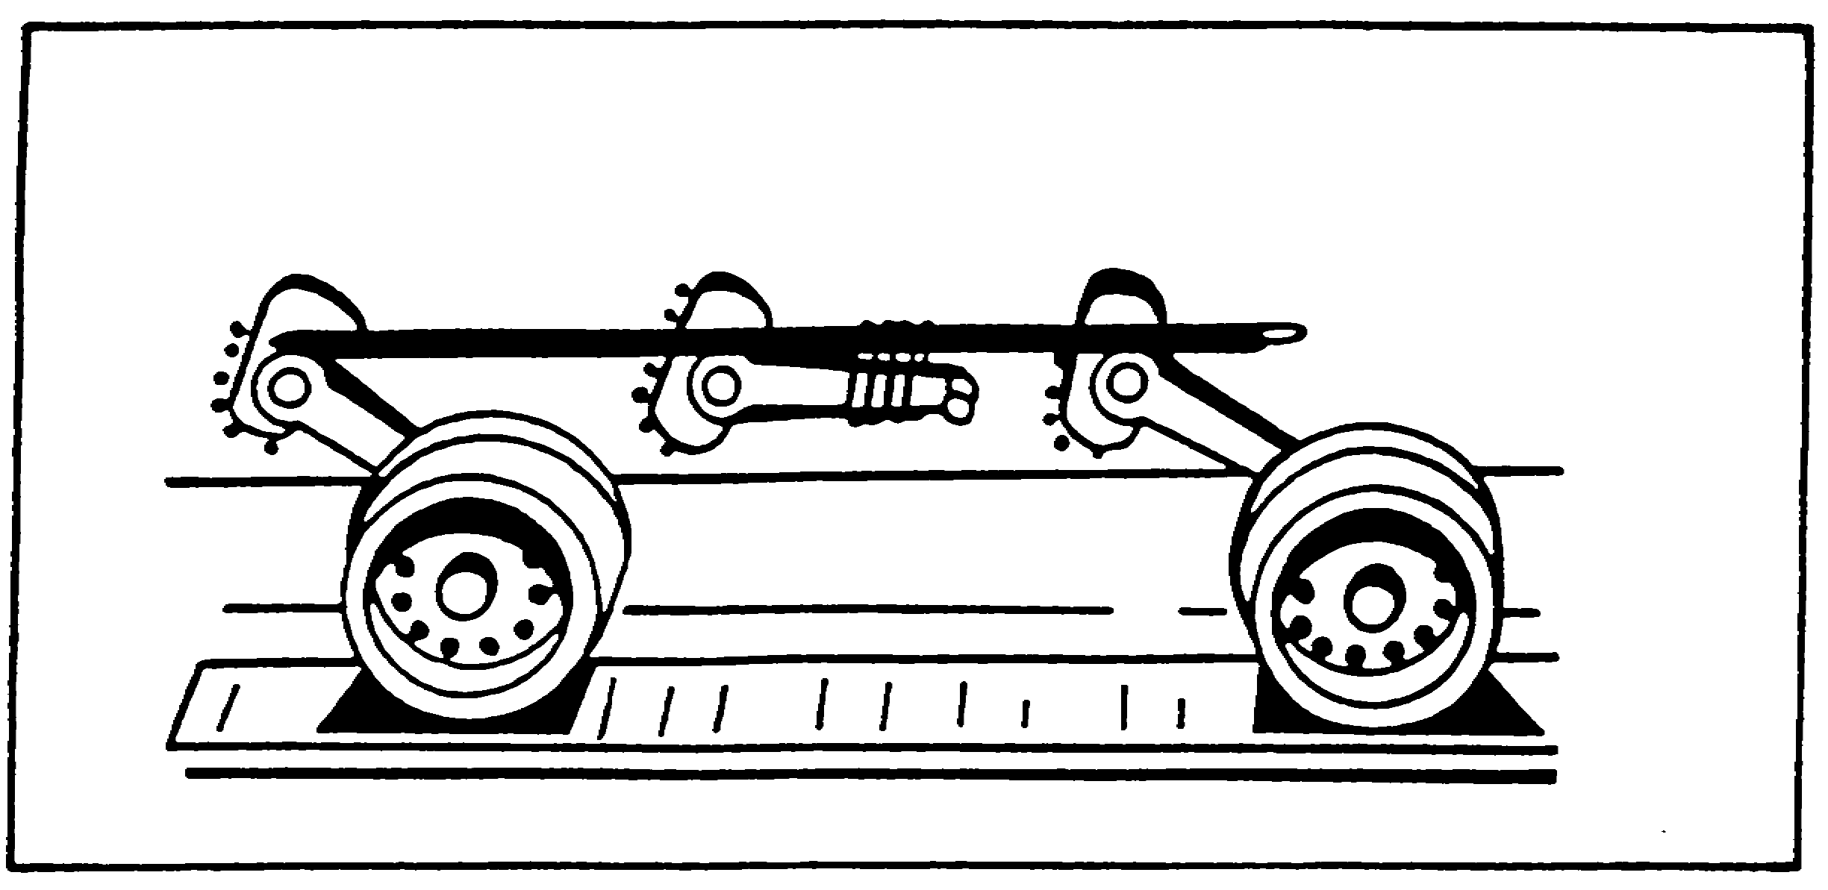

FIGURE 17. BDAR TECHNIQUES FOR DAMAGED
ROADWHEEL ARM.

f. Engine. All the current combat vehicles are powered by diesel fueled engines. Engine operation is monitored by sending units transmitting impulses to dash mounted gages and warning lights. Engine malfunctions can be detected by:

o Abnormal oil pressure or temperature readings or warning lights.

o Abnormal noises.

o Abnormal amounts or coloration of exhaust smoke.

o Sudden loss of power or excessive fuel consumption.

The next subparagraph will give expedient fixes which can restore the vehicle's mobility in the event of engine system failure.

(1) Engine Failure. Basic engines in combat vehicles of a single family, such as the M109 howitzer, are the same, but motor supports, manifolds, exhaust or cooling systems require different brackets to fit a particular vehicle. Accessories and brackets must be swapped from the unserviceable engine to make the replacement engine fit another application.

49

ARTILLERY BDAR - OD1512 - LESSON 1/TASK 2

(a) Engine Interchangeability. Replace engine with any engine that can be converted and installed. Availability of engines may become restricted to those found in damaged vehicles. Basic engines from other vehicles can be modified or reconfigured to fit the vehicle needing the engine. Table 3 shows the interchangeability list. Internal engine components may be different, giving increased or decreased engine performance. The proper engine should be obtained as soon as possible to normalize vehicle operation. Remove transmission connecting links and use the vehicle as a towed firing platform if the firepower systems function. The towed vehicle electrical power will rapidly discharge so use manual controls to conserve power.

TABLE 3. ENGINE APPLICATION - COMBAT VEHICLES.

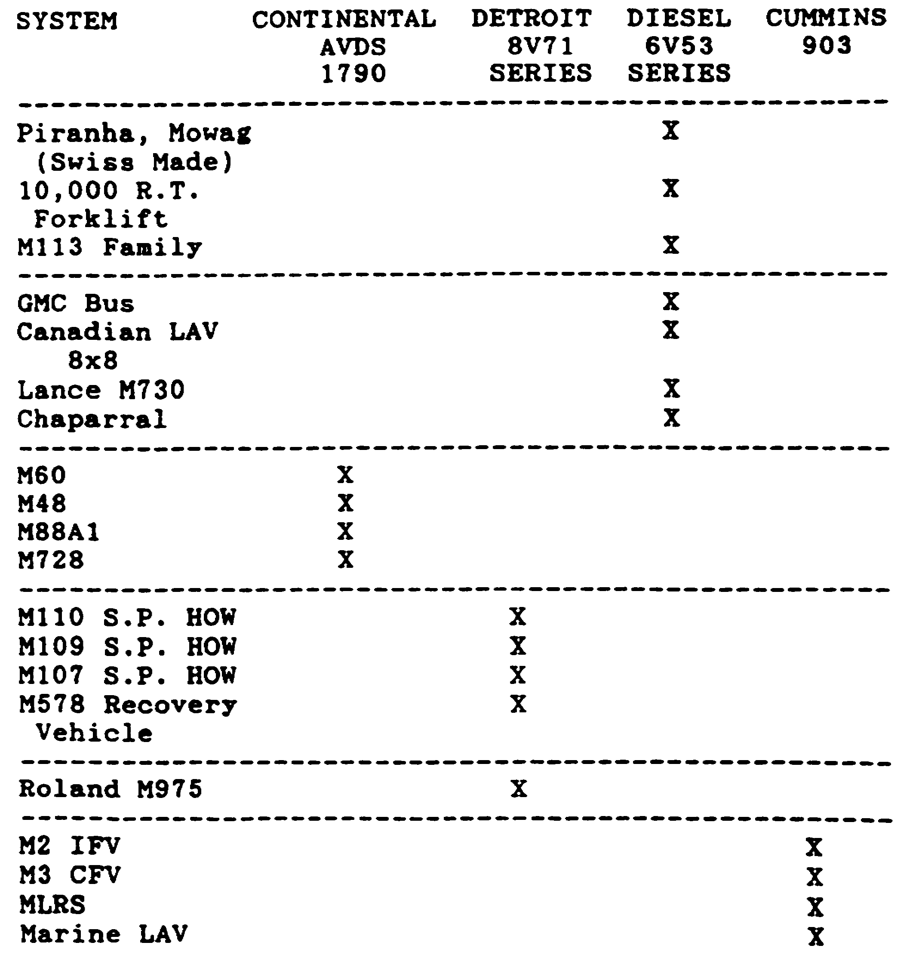

50

ARTILLERY BDAR - OD1512 - LESSON 1/TASK 2

g. Hydraulic Power Distribution. BDAR for a hydraulic system is generally confined to component replacement, expedient line repairs, or bypassing damaged lines. If a hydraulic circuit cannot be repaired, it may be necessary to isolate it (cutting it off) from the system to permit operation of some other hydraulic functions. Damage to the hydraulic systems almost always requires replenishment of lost fluids.

WARNING

Bring the hydraulic system to zero pressure before making any repairs.

(1) Hydraulic High Pressure Metal Tubing Repairs. The following options describe the repair/replacement of high pressure metal lines. Unlike the preceding procedures, the options are within the procedural steps.

Limitations: None

Personnel/Time Required: 2 soldiers/30-90 minutes

Materials/Tools: Hose, hose clamps, AN fittings, MS fittings, tube repair kit, tube cleaner, coupling, tube cutter, hacksaw, swage tool, hand file

Procedural Steps:

OPTION l: MANUFACTURE A NEW LINE. Use the damaged line as a template, or make a template from any available soft wire.

OPTION 2: SUBSTITUTE WITH HIGH PRESSURE HOSE. Make a high pressure hose to replace the damaged line. The temporary hose may follow a different path than the original line and may be easier to install. Clamp the hose to hard supports at convenient intervals to secure the hose.

OPTION 3: PERMASWAGING. Permaswaging fittings may be used to repair damaged tubing. These repairs require cutting out and replacing the damaged tube section. Permaswaging fitting and replacement tubing are rated up to 3000 pounds per square inch (psi) operating pressure. When performing this option, use the repair kit D12323-1-3456, NSN 5180-01-026-0253.

51

ARTILLERY BDAR - OD1512 - LESSON 1/TASK 2

NOTE

Effective, leak-proof permaswaging depends on the tube ends being square, deburred and very clean and on precise marking of tubing to avoid twisting of line (stress) and ensure centering inside fitting(s).

STEP 1. Using a marking pen and a ruler, draw a straight line on the tubing, starting in the undamaged area, through to the damaged section, into the other undamaged area, as shown in figure 18 on the following page. This form of marking is called long axis marking.

STEP 2. Figures 19, 20, 21, and 22 on pages 53 through 55 show four different ways of permaswaging, depending on which figure resembles most of the repair required. Each figure, together with the necessary steps needed to perform the repair depicted in that figure, will be defined in examples 1 through 4.

Example 1: Repair of Pin Hole Leak or Circumferential Crack in Tubing (see figure 19 on the following page)

STEP 3. Make one or two cuts as necessary to enable removal of damaged section. If two cuts are required, the distance between them shall not exceed 0.30 inches. If this measurement is exceeded, the mechanic would go to the repair method described in example 2. Proceed to step 4.

Example 2: Repair of Longitudinal Crack in Tubing (Crack Length Exceeds 0.30 inches) (see figure 20 on page 54)

STEP 3. Make two cuts and remove the damaged section. Prepare a replacement tubing section. Proceed to step 4.

Example 3: Repair of Leaking Tee or Elbow (Permanent Tube Connection Type) (see figure 21 on page 54)

STEP 3. Cut out defective tee or elbow and duplicate tubing sections for each branch. Proceed to step 4.

52

ARTILLERY BDAR - OD1512 - LESSON 1/TASK 2

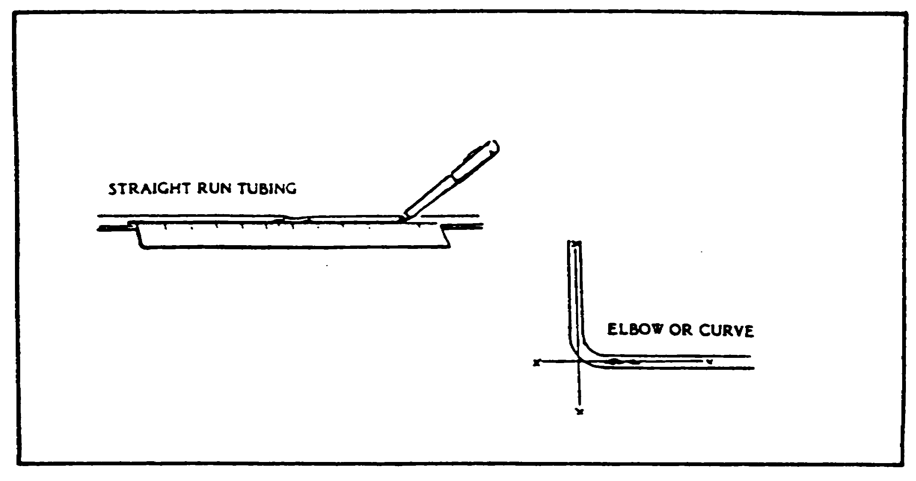

FIGURE 18. LONG AXIS MARKING.

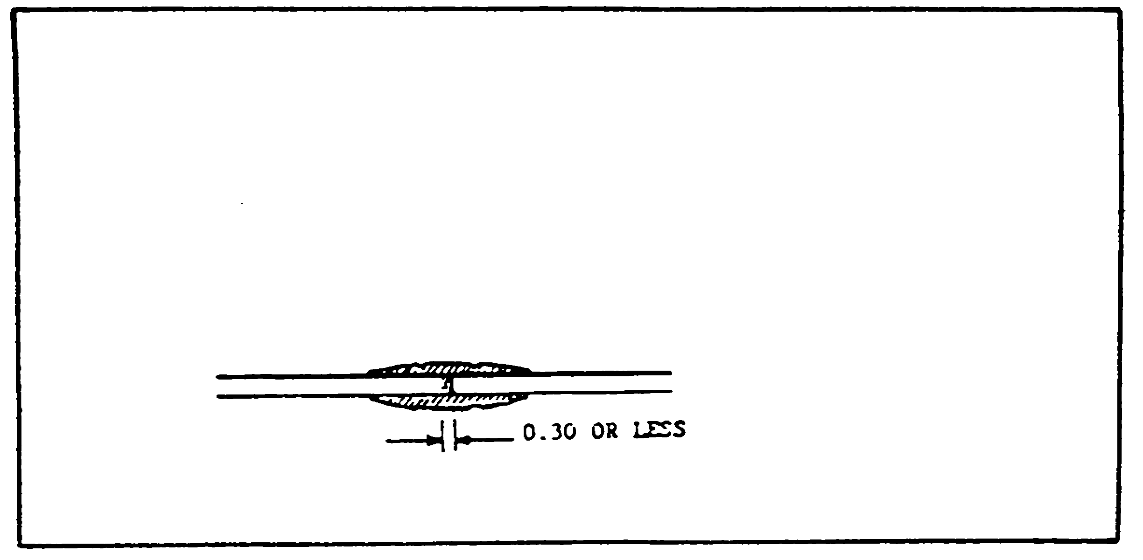

FIGURE 19. REPAIR OF PIN HOLE LEAK OR
CIRCUMFERENTIAL CRACK IN
TUBING.

53

ARTILLERY BDAR - OD1512 - LESSON 1/TASK 2

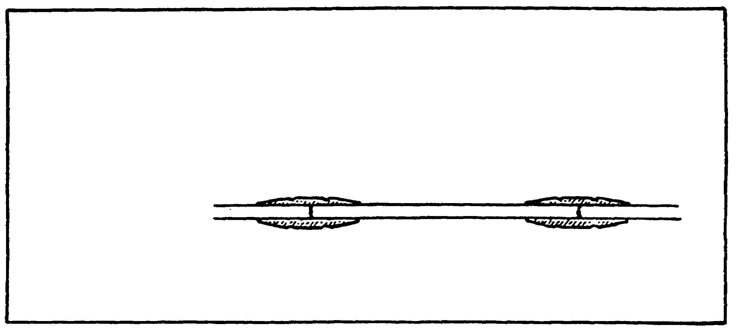

FIGURE 20. REPAIR LONGITUDINAL CRACK
IN TUBING.

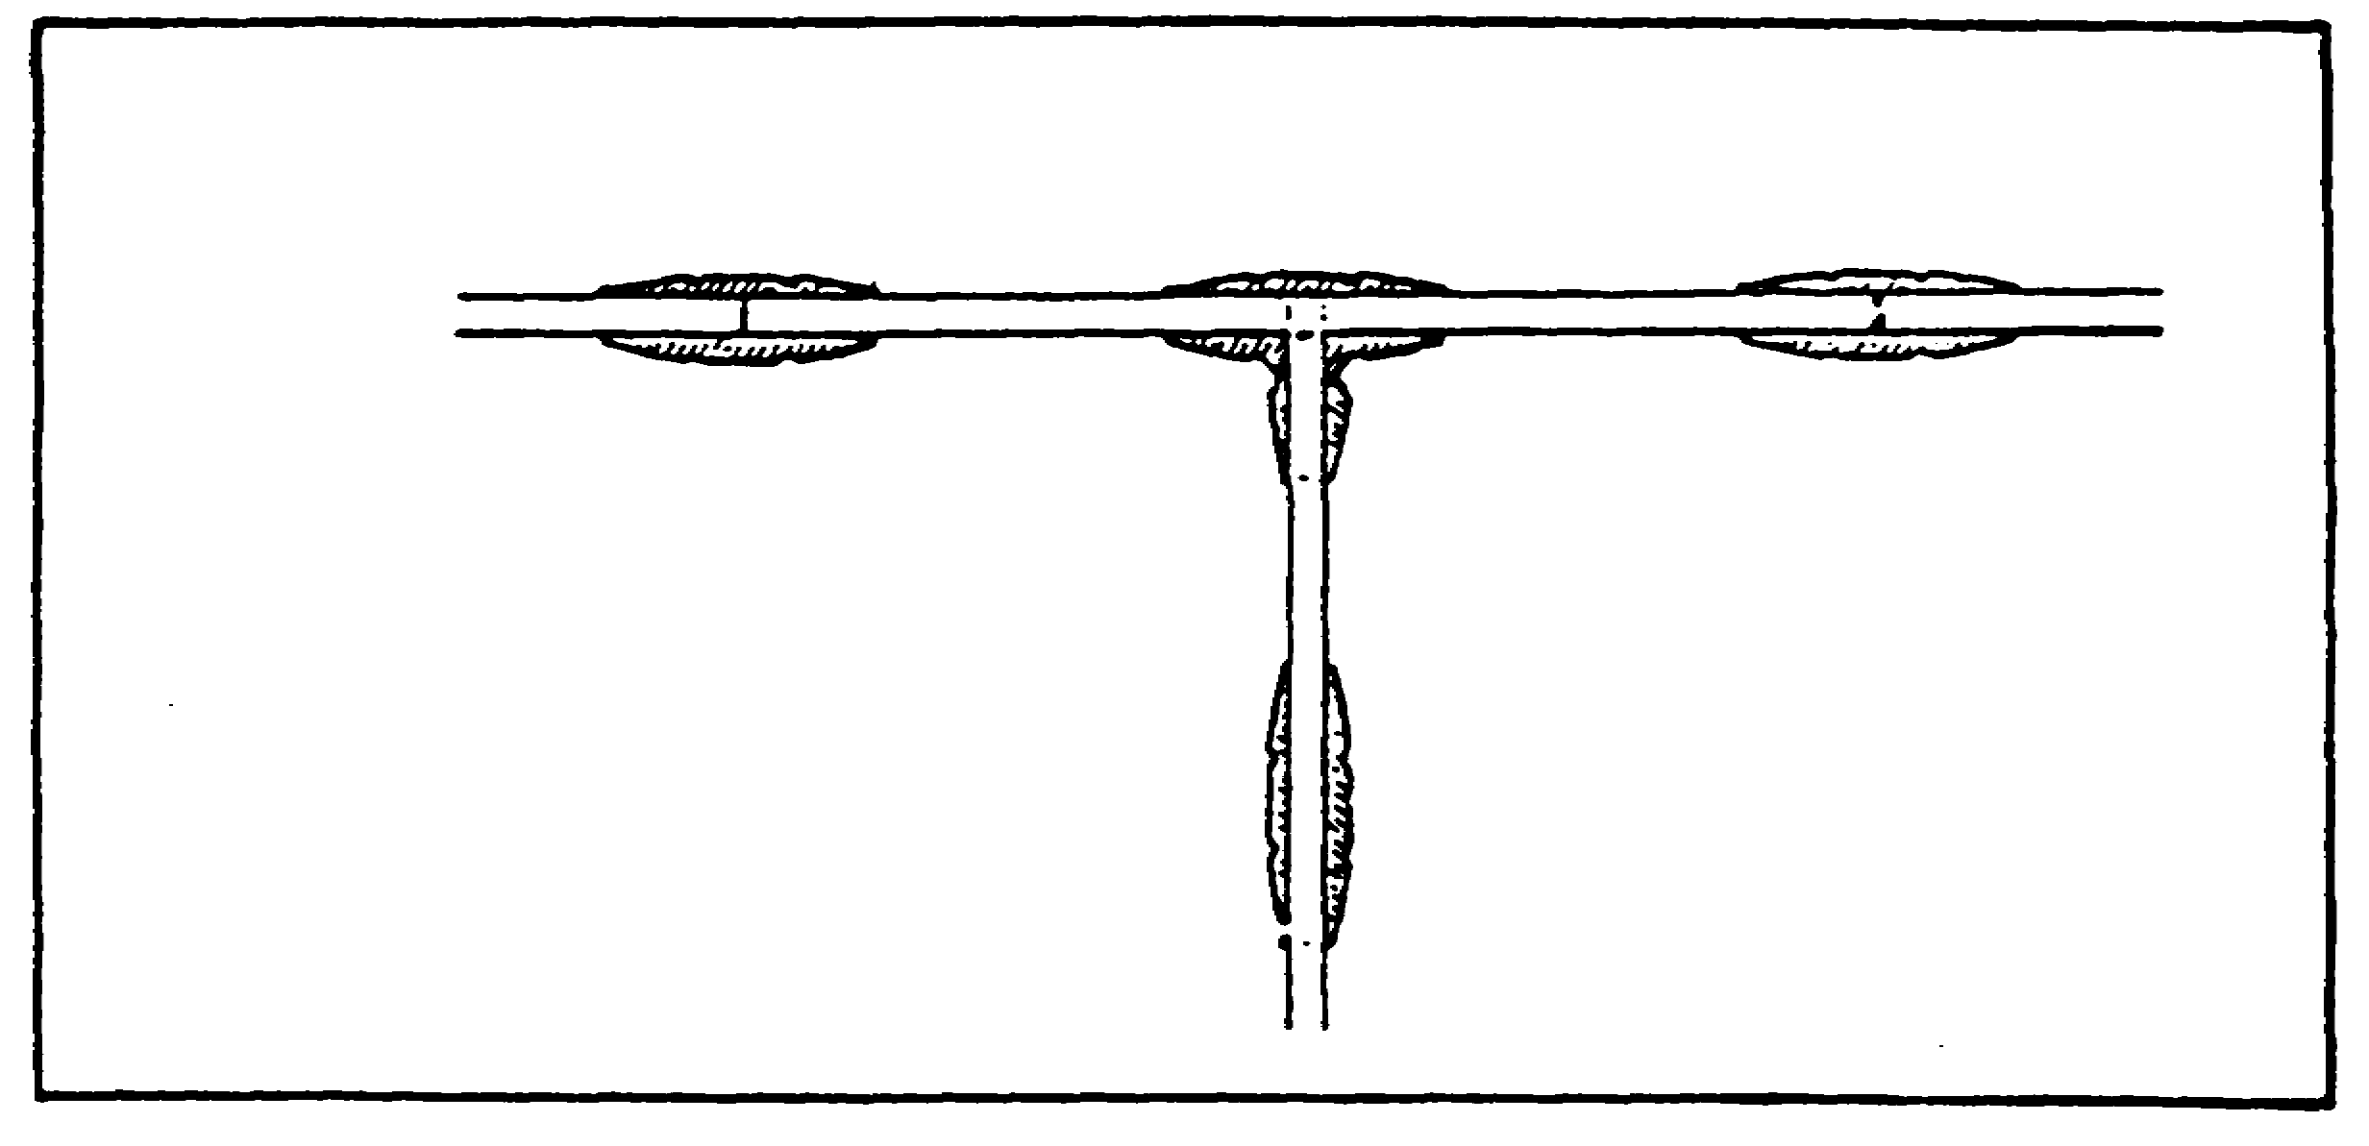

FIGURE 21. REPAIR OF LEAKING TEE OR ELBOW.

Example 4: Repair of Leaking End Fitting (see figure 22 on the following page)

STEP 3. Cut tubing to remove damaged tube end and end fitting. Connect a new end fitting to the mating equipment connection. Cut replacement section to fit between cut tube end and end fitting. Install splice section in new end fitting first and tighten nut as required. Proceed to step 4.

54

ARTILLERY BDAR - OD1512 - LESSON 1/TASK 2

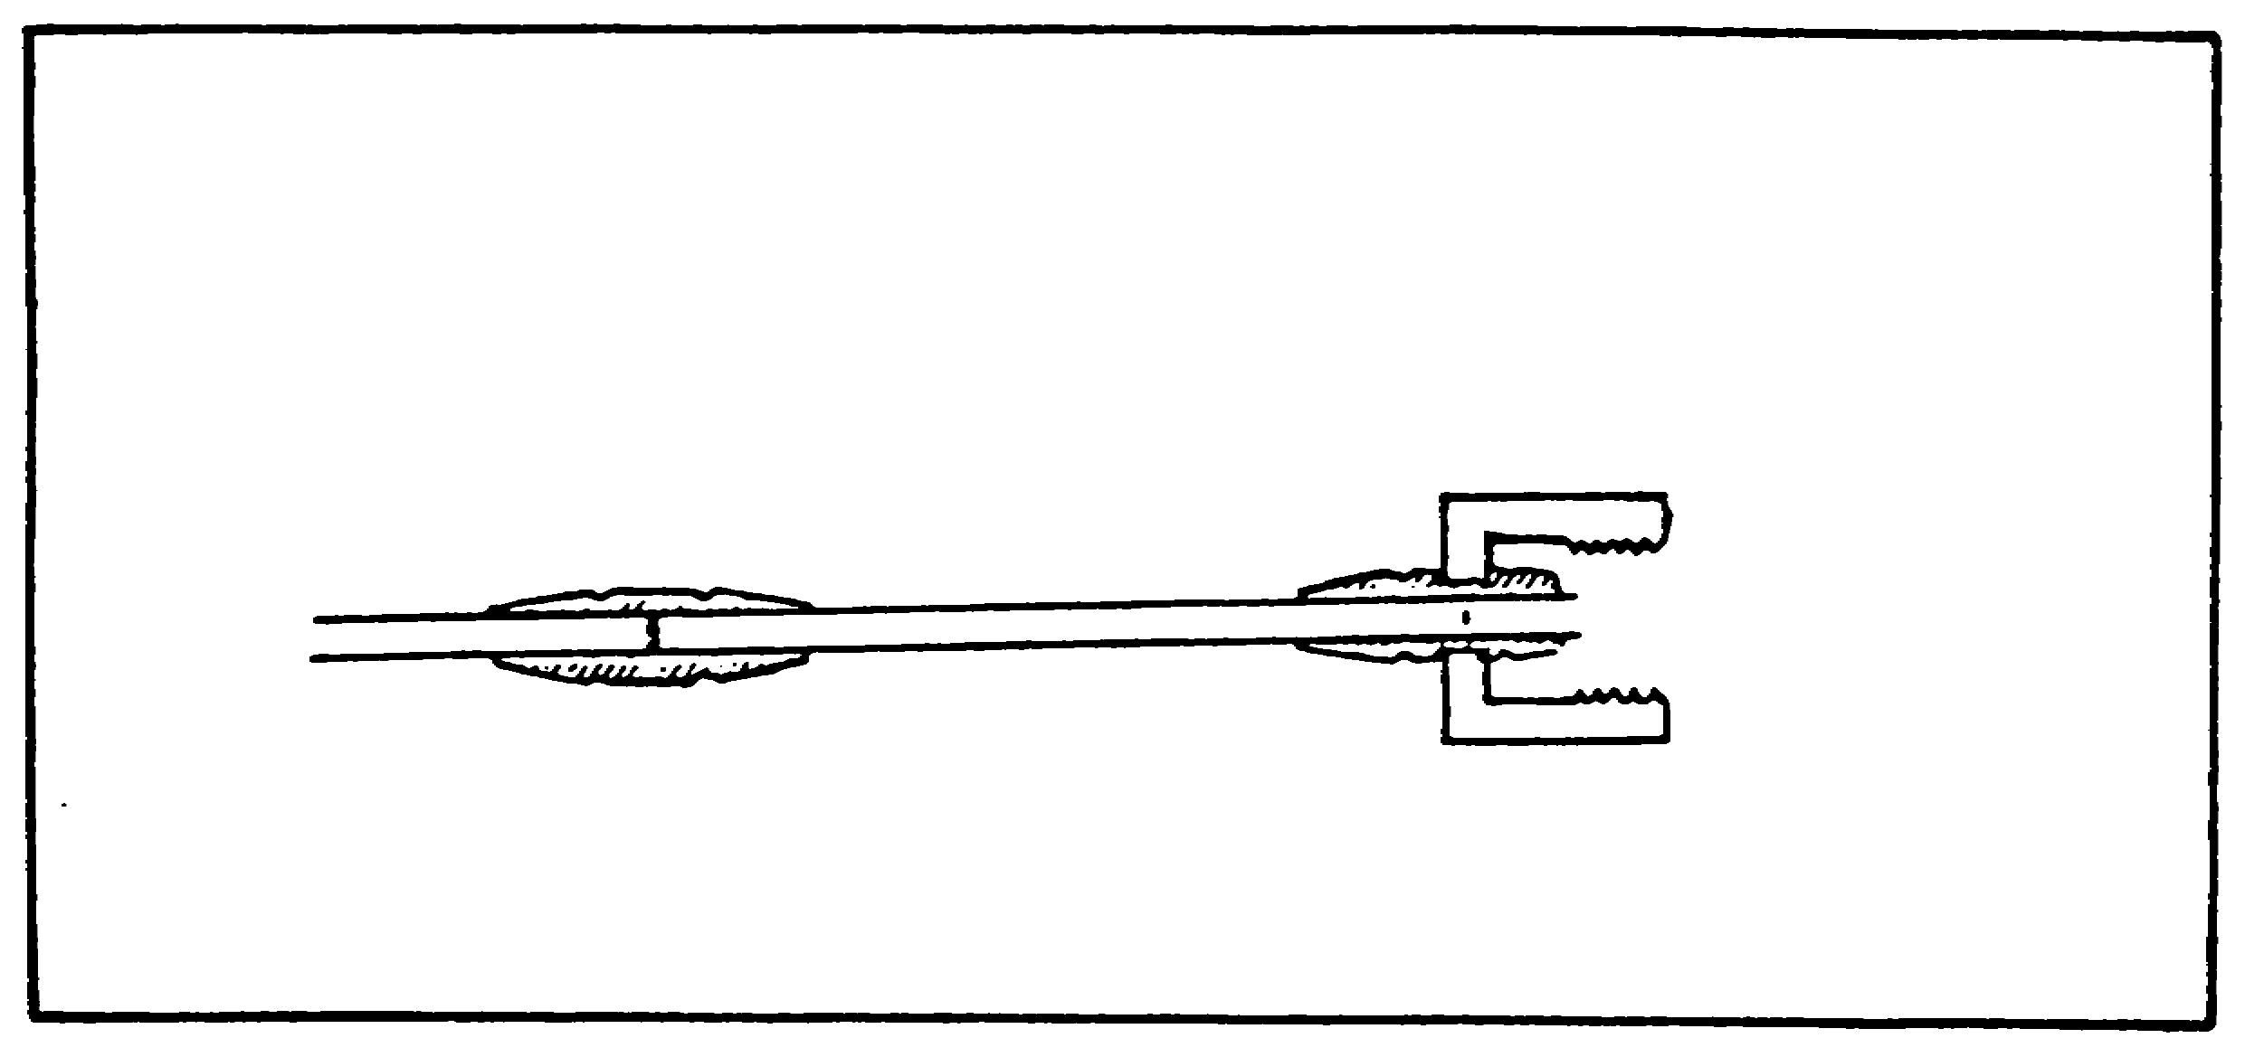

FIGURE 22. REPAIR OF LEAKING END FITTING.

STEP 4. Ends of tubing to be permaswaged must be centered inside the permaswage fitting. Use the permaswaging marking tool and centering/marking instructions supplied with the permaswaging kit. Use the marking method described below only if the marking tool is not available.

(1) Mark half of the overall length of the permaswage fitting on the tubing end as shown in figure 23 on the following page.

(2) Repeat marking procedure on the other tubing end to be swaged.

STEP 5. Slide permaswage fitting(s) all the way on the undamaged tube ends.

STEP 6. Position replacement section between cut ends of undamaged tubing and slide permaswage fittings over gaps between tube ends.

STEP 7. Make sure insertion marks are visible on either side of the fitting. Also, rotate fitting and replacement section until long-axis marking aligns with marking on the undamaged tube end.

STEP 8. Position the permaswage tool on one side of the fitting and swage. Then swage the other side of the fitting (see figure 24 on the following page).

55

ARTILLERY BDAR - OD1512 - LESSON 1/TASK 2

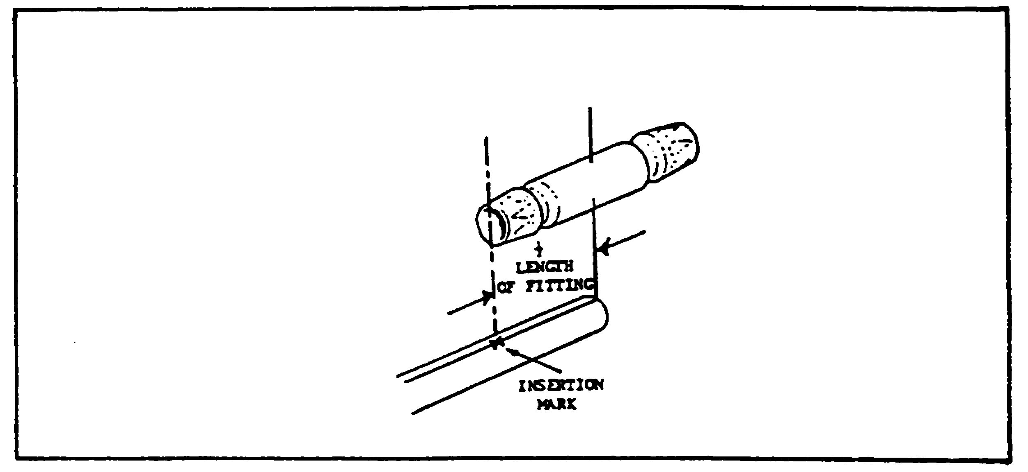

FIGURE 23. TUBE-END MARKING.

STEP 9. Repeat steps 7 and 8 on the other end of the replacement section.

STEP 10. Record the BDAR action taken. When the mission is completed, or as soon as practicable, repair the vehicle using standard maintenance procedures.

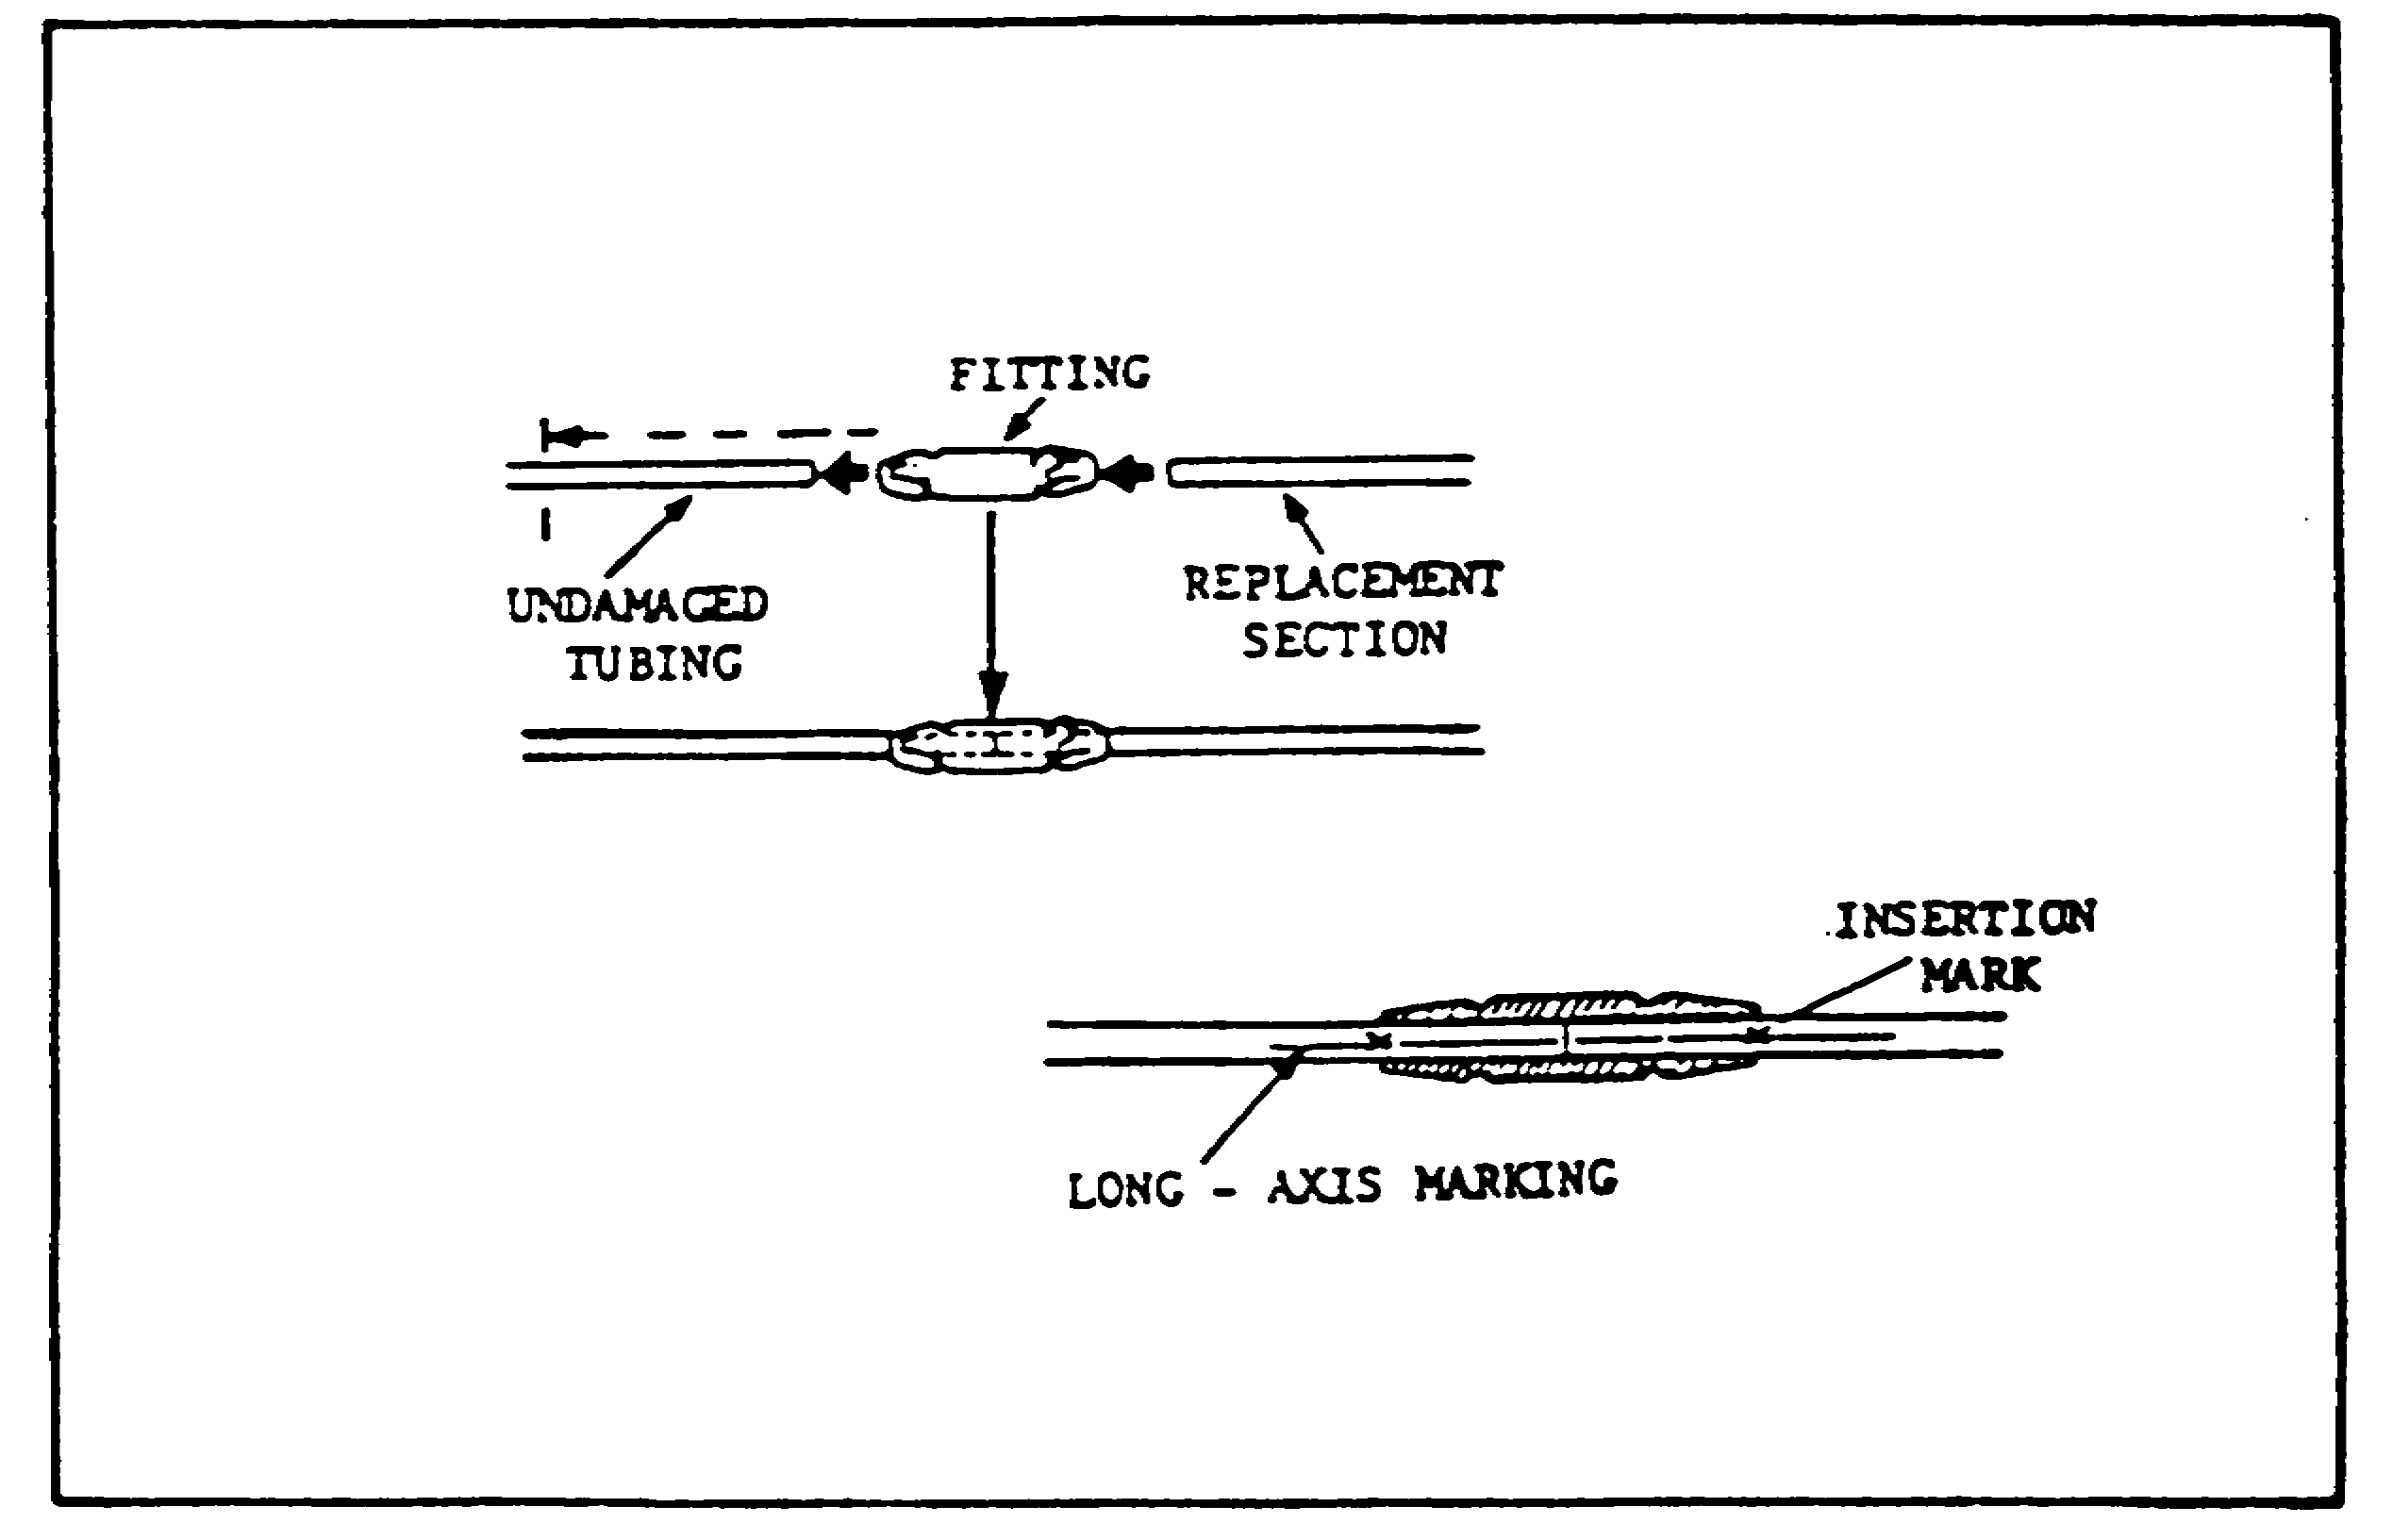

FIGURE 24. PERMASWAGING REPLACEMENT TUBING.

56

ARTILLERY BDAR - OD1512 - LESSON 1/TASK 2

5. Conclusion

This concludes the explanation of assessing and repairing battlefield damaged artillery. The procedures covered in this task were just examples of how to repair a battlefield damaged artillery vehicle expediently. When assessing and/or repairing artillery vehicles using battlefield damage techniques always refer to the vehicle's specific technical manual and also to TM 9-2350-276-BD. One point that should be remembered is that BDAR fixes shall only be used in combat at the discretion of the commander, and shall be repaired by standard maintenance procedures as soon as practicable after the mission is completed.

57

ARTILLERY BDAR - OD1512 - LESSON 1/TASK 2

PRACTICAL EXERCISE 1

1. Instructions

Read the scenario and respond to the requirements that follow the scenario.

2. Scenario

You are a motor pool sergeant involved in a field training exercise (FTX). You have been in the field for 3 1/2 of the 4 week exercise and luckily nothing major has gone wrong until now. Today, one of the M109 howitzers that you are in charge of was hit by a simulated round and your company commander instructs you to repair the vehicle, using battlefield damage assessment and repair procedures. After relating this information to your mechanics, you are amazed by all the surprised looks. You have this strange feeling that they are not too familiar with the BDAR procedures.

To determine how much knowledge your mechanics actually have in BDAR procedures, you decide to give them a sample test.

3. Requirement

Below is a list of questions that you feel will adequately determine the BDAR knowledge of your mechanics. Provide an answer sheet for the questions that follow.

a. Why are field fixes more useful to the MT/MST than to the crew?

b. There are three kinds of assessments performed on damaged equipment. What is the second assessment?

c. Items checked in a vehicle/system assessment procedure must provide __________________________________________________________
_______________________________.

d. When performing a mobility assessment on the track and suspension of an artillery vehicle, what would be done if it is determined that the damage cannot be repaired?

e. What materials are used to fabricate a voltmeter?

58

ARTILLERY BDAR - OD1512 - LESSON 1/TASK 2

f. What is included in the initial damage assessment that the crew provides to the vehicle commander?

g. When a component is cannibalized from a repairable vehicle, what should be done to the space created by the missing part to alert downstream repair personnel quickly that the part has been removed?

h. What liquids cannot be used as a substitute when normal coolants are not available?

i. What are four symptoms of engine malfunctions?

59

ARTILLERY BDAR - OD1512 - LESSON 1/TASK 2

LESSON 1. PRACTICAL EXERCISE - ANSWERS

1. Requirement

a. Field fixes are more useful to the MT/MST for scheduling and accomplishing fix-forward repairs and assessing combat capabilities for reporting to commanders.

b. Whether the damage needs to be repaired.

c. minimum functional combat capability.

d. The vehicle would be recovered.

e. A light bulb and two pieces of wire.

f. Notice of system failure and all major vehicle systems visibly damaged, inoperative or impaired.

g. A tag should be attached in the space created by the missing part.

h. Gasoline and jet fuels.

i. (1) Abnormal oil pressure or temperature readings or warning lights.

(2) Abnormal noises.

(3) Abnormal amounts or coloration of exhaust smoke.

(4) Sudden loss of power or excessive fuel consumption.

60

ARTILLERY BDAR - OD1512 - LESSON 1/TASK 2

REFERENCES

61

ARTILLERY BDAR - OD1512 - LESSON 1/TASK 2

REFERENCES

The following documents were used as resource materials in developing this subcourse:

TM 9-2350-274-BD
TM 9-2350-276-BD

62

